User Operation Manual for Functions Related to EFP on Chinese Government Bond Futures of Submission Software of the Off-Book Trading Platform for Financial Futures
Version V1.00

Chapter I Overview
This document, as designed for new users of the System, provides an overview of and a quick start guide to its functions for EFP transactions on Chinese Government Bond futures.
Chapter Ⅱ describes the most basic operations of the System, including, but not limited to, how to log into and log out of the System and how to use the general functions of the interface.
Chapter Ⅲ provides a detail description of functions related to EFP on Chinese government bond futures.
Chapter Ⅳ discusses in detail operations related to personal information and change of passwords.
Note: Data in relevant screenshots provided herein is give as an example and for reference only.
Chapter Ⅱ Basic Operations
2.1 Login
1. Insert a digital certificate into the USB port.
2. After https://obt.cffex.com.cn is input in a browser, a certificate selection window will pop up in the browser (the following figure is for reference only).
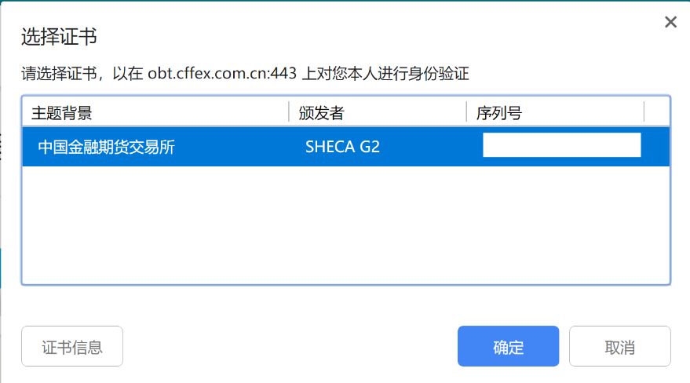
3. Select the corresponding digital certificate for EFP of CFFEX, click the “Confirm” button, and input the password of the digital certificate:
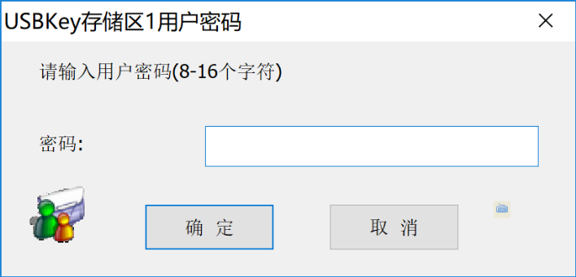
4. Open the home page of the Off-Book Trading Platform as shown below after the digital certificate is successfully validated:
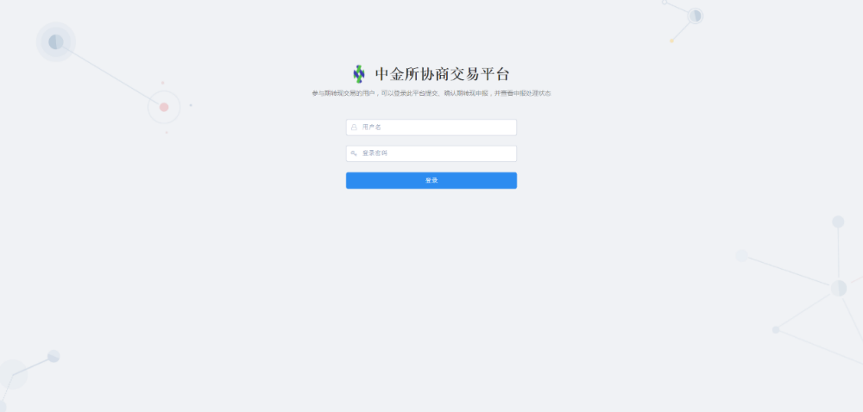
5. Input the user name and password and click the “Login” button. The System will verify whether the user name and password are correct and if correct, will give the prompt of “Successful Login”. Then, enter the System, as shown below:
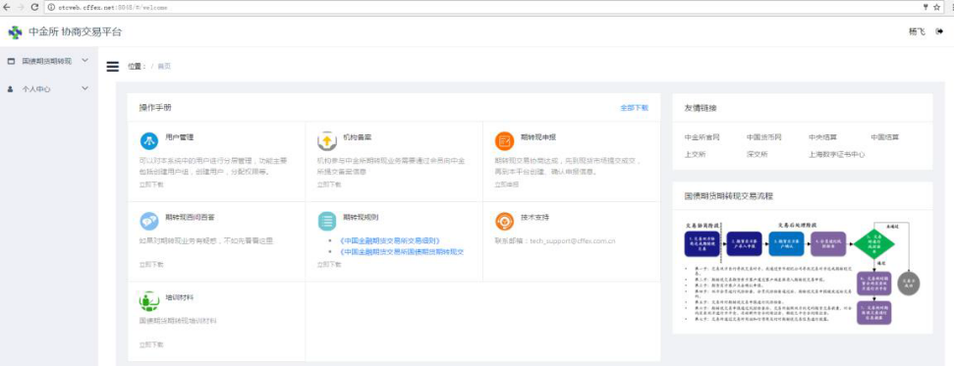
If the user name does not exist, the System will give the prompt of “Non-existent User”; If the password is incorrect, the system will give the prompt of “Incorrect User Name or Password”.
2.2 Logout
Click  next to the user name at the top right of the System’s page to view the “Logout” button. Click the “Logout” button, and the following confirmation dialog box will pop up:
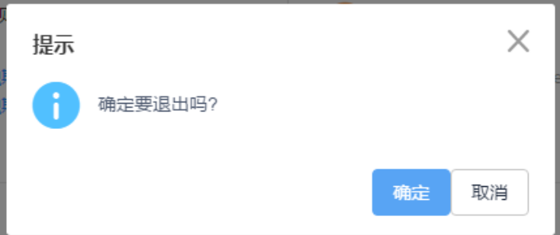
Click the “Confirm” button to log out of the System and the “Withdraw” button to withdraw the log-out operation and return to the System.
Chapter Ⅲ EFP on Chinese Government Bond Futures
This part mainly describes the creation and confirmation of EFP reports as well as their related operations.
3.1 Create EFP Report
Description of Function:
After the parties to an EFP transaction reaches agreement on the elements of such EFP transaction, the seller of the futures contract creates and submits to the buyer of the futures contract for confirmation an EFP report through this function.
Instructions:
1. Click the menu to enter the “Create EFP Report” function interface. An EFP report is created by the seller of the futures contract and confirmed by the buyer of the futures contract. Input boxes marked with an asterisk* must be completed.
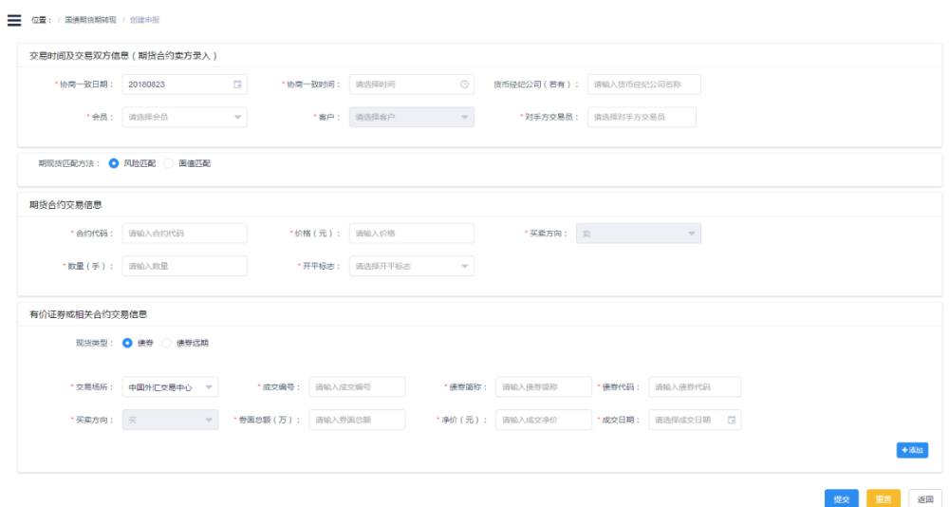
2. Transaction time and information of the parties (to be input by the seller of the futures contract):
a) Date of agreement: it is the date when the parties to an EFP transaction agree upon the EFP transaction and by default, is the current date. The parties may agree upon the EFP transaction during or outside the trading hours of the Exchange, but according to applicable rules, such data cannot be earlier than the previous trading day or later than the current trading day. The date of agreement can be selected in the following way:
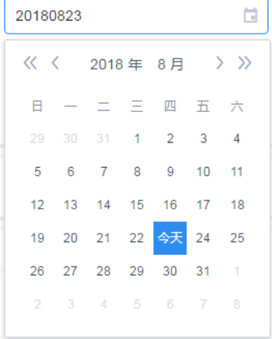
b) Time of agreement: it is the time when the parties agree upon the EFP transaction. The parties may agree upon the EFP transaction during or outside the trading hours of the Exchange, but according to applicable rules, if the date of agreement is earlier than the current trading day, the time of agreement must be between 9:15 a.m. and 10:15 a.m. (subject to time specified in applicable business rules) or if the date of agreement falls on the current trading day, the time of agreement must be later than 9:15 a.m. A time point in the future cannot be provided as the time of agreement. The time of agreement can be selected in the following way:
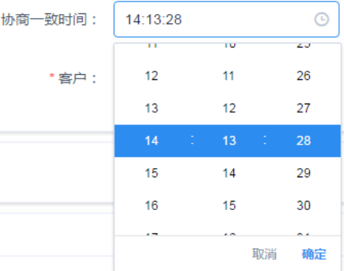
c) Money broker (if any): If the agreement upon the EFP transaction is reached through a money broker, provide its name in this input box, and if not, leave this input box blank.
d) Member: member available for selection in the drop-down list is the carrying member of the institution of the currently logged-in user who has registered for such user.
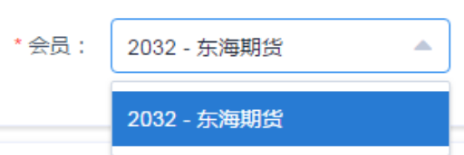
e) Client: clients available for selection in the drop-down list are those of the selected member who meet the requirements for the type of clients qualified to enter into EFPs and have its certificate number identical to that of the institution of the currently logged-in user. If the client is an asset management scheme, it will be identified by the organization code of the member.
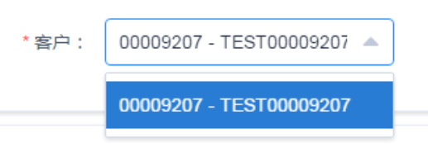
f) Counterparty trader: with an editable drop-down list, the System will show up to ten filter results based on the input of a user. Traders available for selection in the filter results are all trader users in the System other than the currently logged-in user. If no expected trader is shown in the drop-down list, more information may be input to allow the System to recommend a counterparty more accurately.
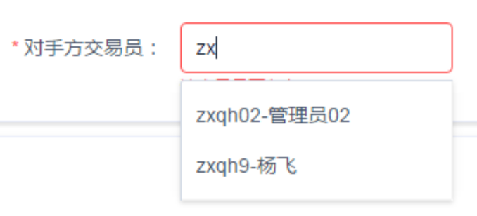
3. Matching method: only one of the two methods, i.e. equivalence of risk and equivalence of face value, can be selected. If the former method is selected, the Exchange will conduct a subsequent examination on the matching of the futures and physical based on their point basis value; If the latter method is selected, the System will verify whether the face value of the futures transaction is equal to the total face value of the physical transaction (if there are more than one physical transactions, the total face value of all such physical transactions)and if not, the EFP report cannot be submitted.

4. Trading information on the futures contract:
a) Contract code: the contract code is input by text, and the System will automatically convert the text into upper case letters. After the completion of the input, the System will verify whether the contract is legitimate by mainly determining whether the contract is currently available for the EFP transaction and will show the daily price fluctuation limit of the contract below the “Price (yuan)” input box.

b) Price (yuan): the price is input by text and must be within the price fluctuation limit.

c) Trading direction: by default, it is sell and not required to be edited.

d) Quantity (lots): it is input by text and must be a positive integer.
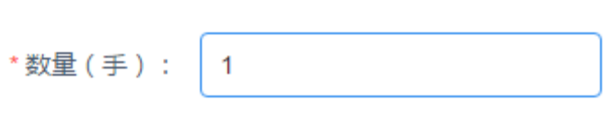
e) Position opening/closing flag: position opening or closing can be selected in the drop-down list.
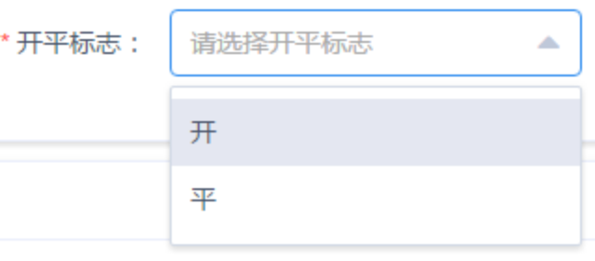
5. Trading information on marketable securities or related contracts (“physical”): According to the applicable EFP rules, an EFP transaction may involve one or more physical transactions which can be managed through the “Add” and “Delete” buttons.
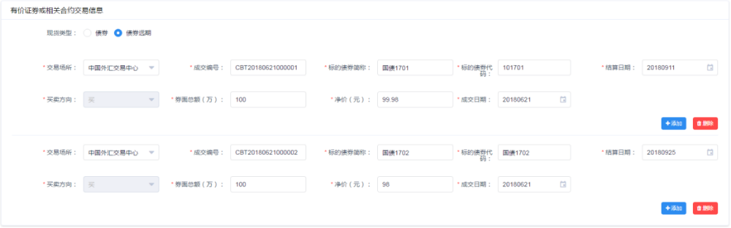
a) Type of physical: bonds or bond forwards are available for selection. Currently, the scope of bonds used for the physical transaction in an EFP transaction on Chinese government bond futures are coupon bonds, while bond forwards are coupon bond based forward contracts. A bond forward transaction has one more settlement date than a transaction in the underlying bond. There can be only one type of physical in an EFP transaction.

b) Trading venue: China Foreign Exchange Trading System, Shanghai Stock Exchange and Shenzhen Stock Exchange are available for selection in the drop-down list.
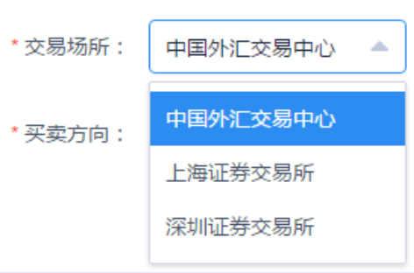
c) Transaction number: it is the transaction number for the physical transaction on a spot trading venue and input by text. A physical transaction can be involved in only one EFP transaction, and the System will, based on the combination of transaction number, transaction date and trading venue, examine the physical transaction to prevent the transaction from being involved in other EFP transactions.
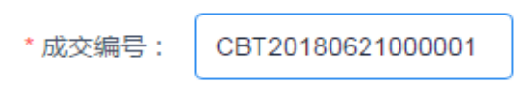
d) Bond code (the underlying bond code if the “bond forward” is selected as the type of bonds): If the “equivalence of face value” is selected as the matching method, only the code of bonds deliverable under the futures contract can be input in this input box. The System allows for fuzzy matching of bond codes to enable rapid selection of bond codes by users.
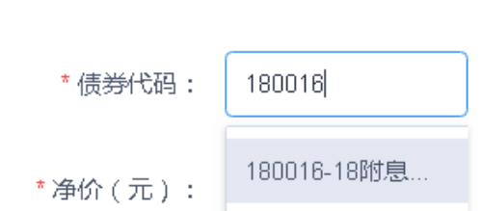
If a bond code input by a user is inconsistent with the requirements of the applicable rules upon the examination of the System, the System will display the “Explanation and Undertaking” input box for the user to complete:

If the user finds that it has input a wrong bond code, the input box will disappear after the wrong bond code is corrected. In case that the user confirms the correctness of the input bond code, but suspects that there is an error in the examination of the System, the provision of an explanation will not affect the creation of an EFP report.
e) After a bond code is selected, the System will automatically provide the short name of the bond in this input box.
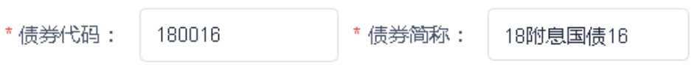
f) Trading direction: it is buy by default and not required to be provided.

g) Total face value (ten thousand): it is input by text.

h) Net execution price (yuan): it is the execution price of the physical transaction and input by text.

i) Transaction date: it is the date on which the physical transaction is executed and must be identical to the date of agreement. If there are more than one physical transactions, their transaction dates must fall on the same date.
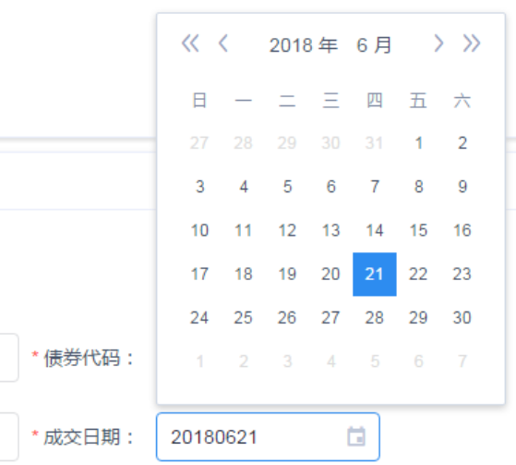
j) Settlement date: this input box is required to be completed if the “bond forward” is selected as the type of physical. Such date cannot be earlier than the last trading day of the futures contract.
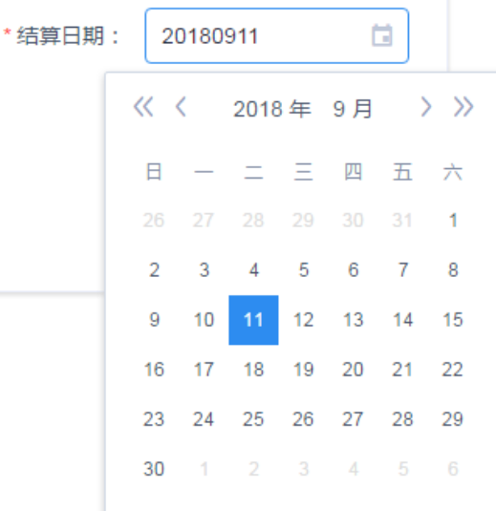
6. Click the “Add” button to add information on a physical transaction.
7. Click the “Delete” button to delete information on a physical transaction.
8. Click the “Submit” button to input a trading password in the confirmation dialogue box. If the trading password so input is incorrect, the System will give the prompt of “Incorrect Password”.
9. Click the “Confirm” button, and the System will give the prompt of “Successfully Submitted” upon successful verification and in case of unsuccessful verification, will return a corresponding error message.
10. Click the “Reset” button to clear the provided information.
11. Click the “Return” button to return to the “Query about EFP reports” interface.
3.2 Query about EFP Reports
This function allows EFP report information created by a current user to be looked up, viewed in detail, withdrawn, deleted, and re-submitted.
3.2.1 Query
Description of Function:
This function is intended to view EFP reports based on query conditions.
Instructions:
1. Click the menu to enter the “Query” page where EFP reports submitted by the current user can be looked up based on the default query conditions. It is also possible to modify the query conditions and click the “Query” button to look up EFP reports.
2. Make adjustment to the order of EFP reports based on EFP report number and time.
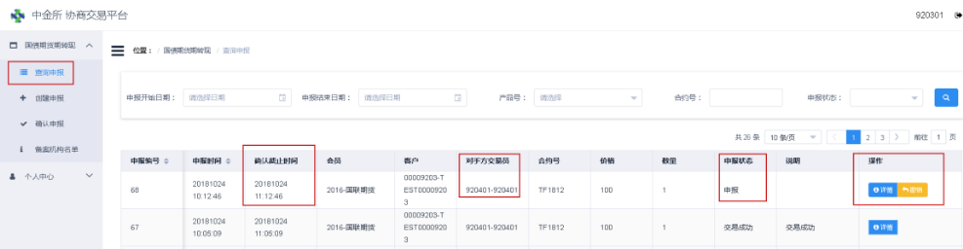
3. The detailed information of all EFP reports can be viewed by clicking the “Details” button.
4. An “withdrawal” operation can be conducted with respect to EFP reports with the status of “Submitted”.
5. An “re-submit” operation can be conducted with respect to EFP reports with the status of “EFP Transaction Failed”
6. An “deletion” operation can be conducted with respect to EFP reports with the status of “Withdrawn”.
3.2.2 Details
Description of Function:
This function is intended to view the detailed information of EFP reports.
Instructions:
1. Click the “Details” button displayed in an EFP report query results to enter the “Details of EFP Reports” interface where the detailed information of an EFP report can be viewed.
2. Click the “Return” button to return to the main interface.
3.2.3 Withdraw
Description of Function:
EFP reports with the status of “Submitted” can be withdrawn through this funciton, which means that once being confirmed by the counterparty, an EFP report cannot be withdrawn.
Instructions:
1. Click the corresponding “Withdraw” button displayed in an EFP report query result, and a confirmation dialouge box for withdrawal of the EFP report will pop up.
2. Click the “Confirm” button to withdraw the EFP report, and the System will give the prompt of “Successfully Withdrawn”.
3. Click the “Cancel” button to cancel the withdrawal operation and return to the main interface, and the System will give the prompt of “Withdrawal Cancelled”.
4. If the counterparty confirms the EFP report while it is being withdrawn, the withdrawal operation will fail, and the System will give the prompt of “Non-withdrawable EFP Report”.
3.2.4 Delete
Description of Function:
EFP reports already withdrawn can be deleted through this function.
Instructions:
1. Click the corresponding “Delete” button displayed in an EFP report query result, and a confirmation dialogue box for deletion of the EFP report will pop up.
2. Click the “Confirmation” button to delete the EFP report, and the system will give the prompt of “Successfully Deleted”.
3. Click the “Cancel” button to cancel the deletion operation and return to the main interface, and the System will give the prompt of “Deletion Cancelled”.
4. If the counterparty confirms the EFP report while it is being withdrawn, the withdrawal operation will fail, and the System will give the prompt of “Non-withdrawable EFP Report”.
3.2.5 Re-submit
Description of Function:
An EFP report where the EFP transaction in question fails can be re-submitted through this function. This function is mainly intended to make it easy for users to efficiently re-submit an EFP report in the event of failure of the EFP transaction due to some input errors.
Instructions:
1. Click the corresponding “Re-submit” button displayed in an EFP report query result to enter the “Re-submit” page:
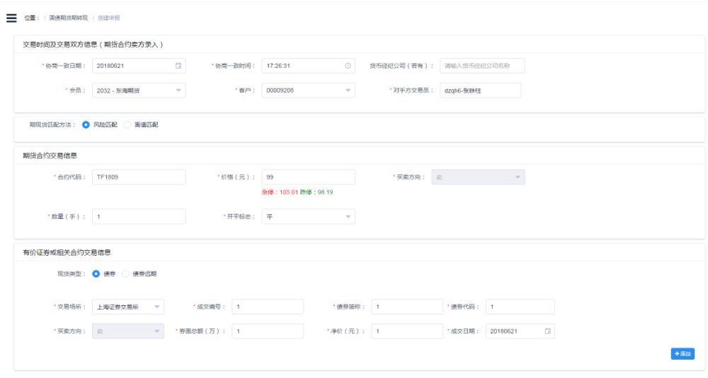
2. The EFP report elements in the page have been automatically completed according to the information of the previous EFP report where the EFP transaction failed. If necessary, a user may edit the information. Input rules and subsequent operations are the same as those for creation of EFP reports.
3.3 Confirm EFP Reports
Through this function, the trader of the buyer of the futures contract in an EFP transaction can confirm the EFP report information submitted by the seller of the futures contract and provide the buyer’s information.
3.3.1 Query
Description of Function:
This function is intended to view EFP reports based on query conditions.
Instructions:
1. Click the menu to enter the “Query” page where EFP reports which can be or have been confirmed by the current user can be looked up based on the default query conditions. It is also possible to modify the query conditions and click the “Query” button to look up EFP reports.
2. Make adjustment to the order of EFP reports based on EFP report number and time.
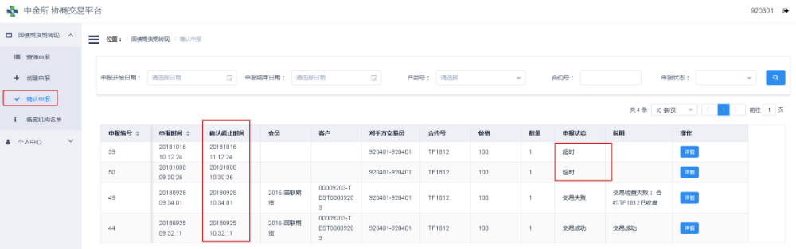
3. An “View Details and Confirm” operation can be conducted with respect to EFP reports with the status of “Reported”.
4. An operation to view “Details” can be conducted with respect to EFP reports with any other status.
3.3.2 View Details and Confirm
Description of Function:
The trader of the buyer of the futures contract in an EFP transaction can view the detailed information of and confirm the EFP report through this function. The EFP report must be confirmed before the confirmation deadline and if not so confirmed, will be set as “Beyond the Deadline”.
Instructions:
1. Click the “View Details and Confirm” button displayed in an EFP report query result to enter the “Confirm EFP Reports” page.
2. All information of the seller other than its member, client and position opening/closing flag can be viewed in the page.
3. Input the buyer’s member, client and position opening/closing flag.
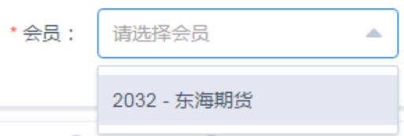
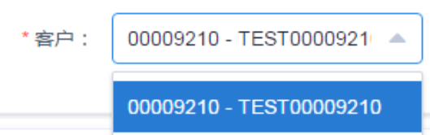
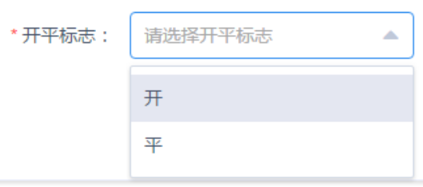
4. Click the “Confirm” button, and an input box for the trading password will pop up. If the trading password so input is incorrect, the System will give the prompt of “Incorrect Password”.
5. Click the “Confirm” button, and the System will give the prompt of “Successfully Confirmed” upon successful verification and in case of unsuccessful verification, will return a corresponding error message.
6. Click the “Return” button to return to the “Query about EFP Reports” interface.
3.3.3 Details
Description of Function:
This function is intended to view the detailed information of EFP reports.
Instructions:
1. Click the corresponding “Details” button displayed in an EFP report query result to enter the “Details of EFP Reports” interface where the detailed information of an EFP report can be viewed.
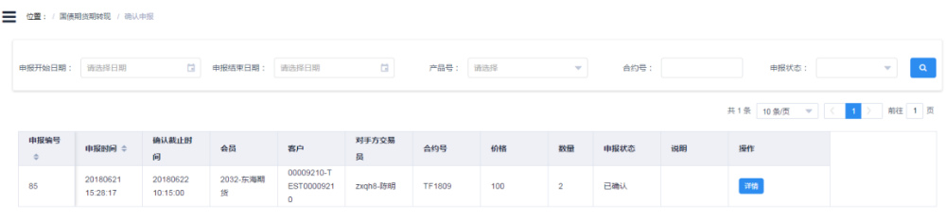
2. Click the “Return” button to return to the main interface.
3.4 List of Registered Institutions
3.4.1 Query
Description of Function:
This function is intended to view the list of successfully registered institutions.
Instructions:
1. Open the menu to display information on the list as below:
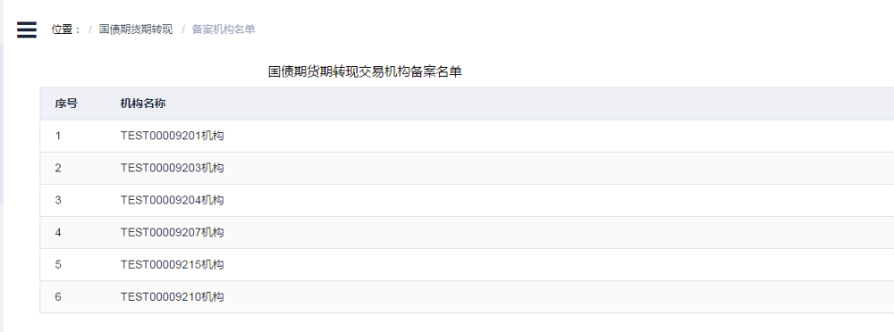
Chapter VI Personal Information
This part mainly describes operations related to personal information and change of passwords.
4.1 Personal Information
Description of Function:
This function is intended to view the personal information of the currently logged-in user.
Instructions:
1. Click the menu to enter the “Personal Information” page where personal information can be viewed.
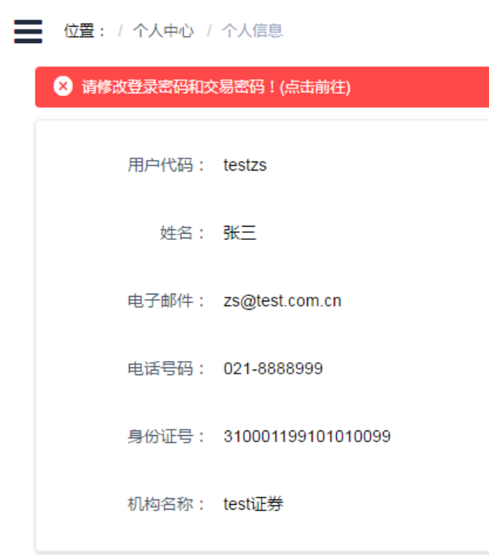
4.2 Change Login Password
Description of Function:
This function is intended to change the login password of a current user for the Off-Book Trading Platform. A user cannot create or confirm an EFP report by using the initial password of its account and can conduct such operations only after changing the initial password.
Instructions:
1. When a user with the permission to create or confirm an EFP report logs into the System by using the initial password, the System will prompt that “Please Change the Login Password and Trading Password by Clicking Here”. 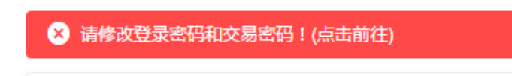
2. Click the link above to enter the “Change Login Password” page or directly click the “Change Login Password” menu to enter this page.
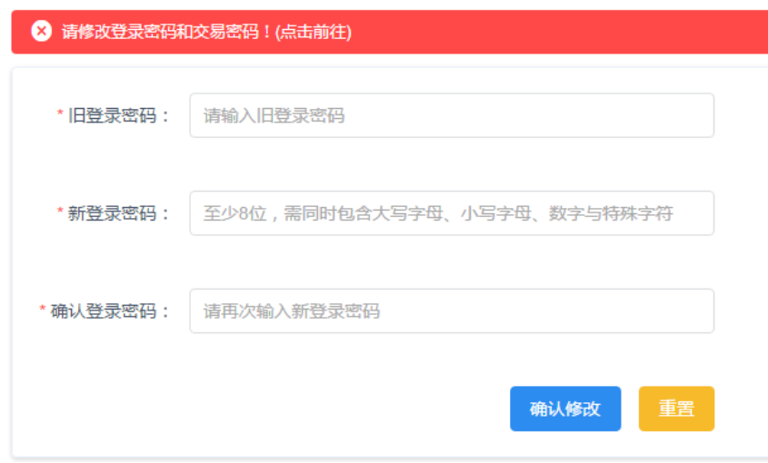
3. Input the old login password and new login password and confirm the new login password. The rule for setting of login passwords: a password should have at least 8 characters which combine upper case letters, lower case letters, numbers and special characters.
4. Click the “Confirm Change” button, and the System will pop up a confirmation dialog box for change of password as shown below. Click the “Confirm” button to submit the changed login password.
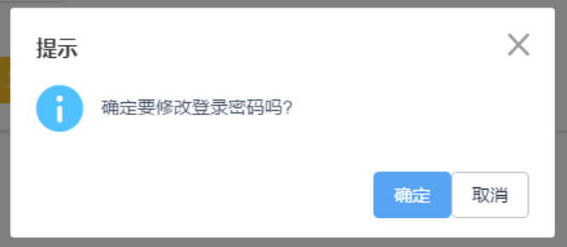
5. After the password is successfully changed, the System will jump to the login interface for re-login.
6. The prompt of “Please Change Login Password” will disappear after the initial login password is changed.
4.3 Change Trading Password
Description of Function:
This function is intended to change or set a trading password used by a current user to enter into an off-book trade. No trading password is set for an initial account. When a user with the permission to enter into an off-book trade logs into the System, the System will remind the user to change its trading password. If the user fails to do so, it cannot create or confirm EFP reports.
A user may also change its trading password based on its own needs.
Instructions:
1. Click the menu to enter the “Change Trading Password” page, and if no trading password has been set, see the following page:
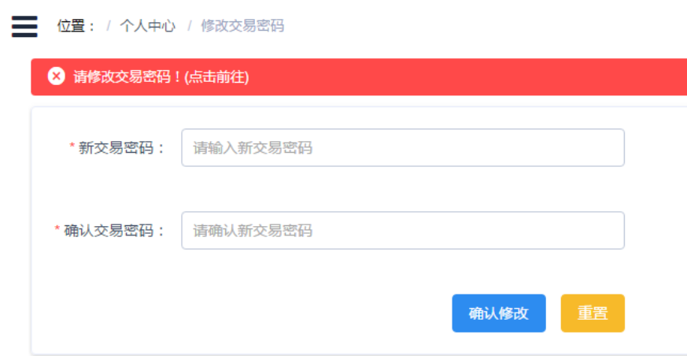
2. Input a trading password twice to confirm that the password is correctly input. The trading password so set should contain 6 numbers. Click the “Confirm Change” button to submit the changed trading password.
3. If a trading password has previously been set, input both the new trading password and the old trading password when changing the old trading password.
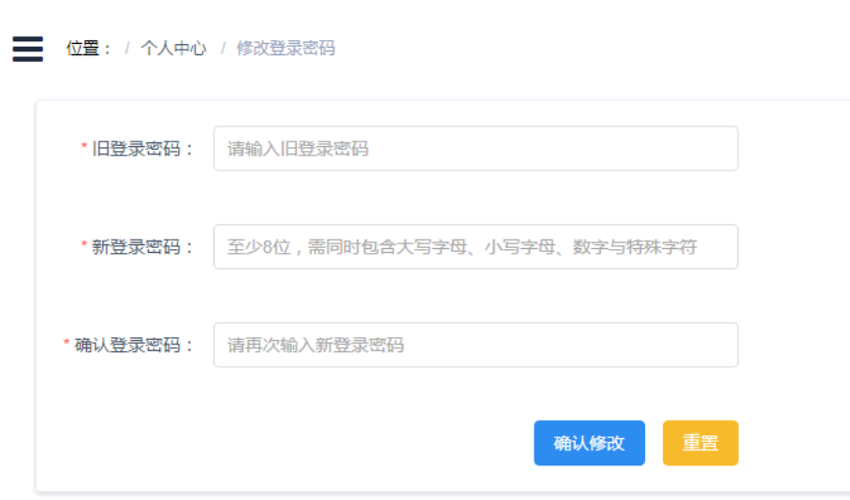
4. The prompt of “Please Change Trading Password by Clicking Here” will disappear after the trading password is set.

