Installation of Digital Certificate for Simulated Testing and Access to Off-Book Trading Platform
This document only describes the method for clients to obtain and install software digital certificates and use them to access the Off-Book Trading Platform during the course of simulated trading on CFFEX.
1 Simulated Environment
1.1 Obtaining Software Digital Certificate
After completing the registration of an institution, a member contacts the Information Department of CEEFX by email to obtain an institution administrator account and a digital certificate for testing from CFFEX and then sends them to the contact person designated by the institution.
Please be noted that the digital certificate for the simulated environment is a hardware-free software certificate issued by the Information Department of CEEFX without applying to SHECA.
1.2 Installing Digital Certificate
After receiving the certificate, the institution double-clicks the certificate file “client. p12” to import it. The password for the installation of the certificate is cffex2018. The procedures for the installation of the certificate are as below:
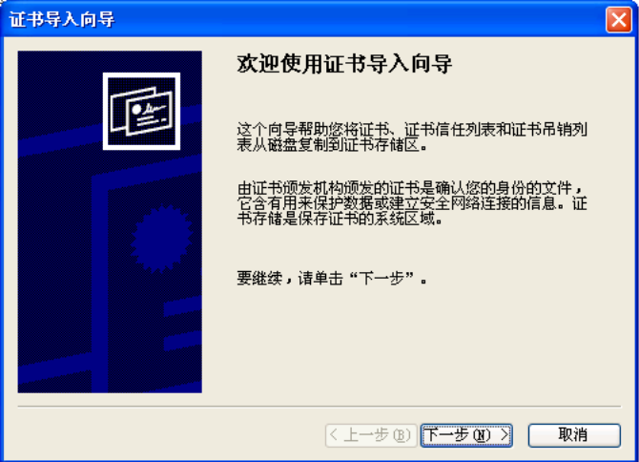
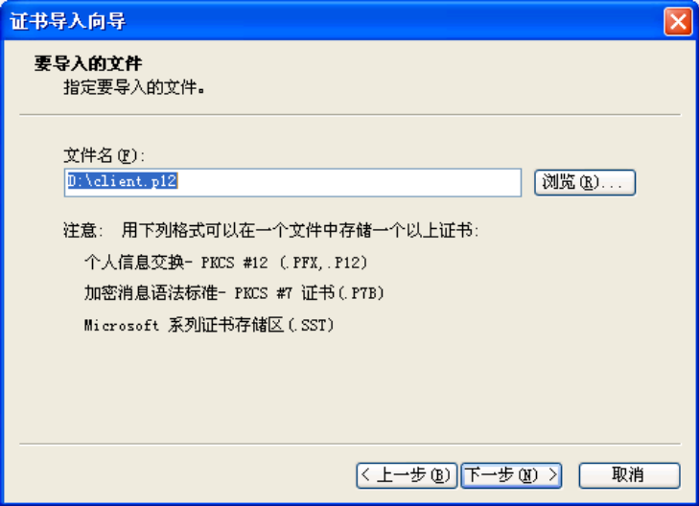
Input the password of cffex2018 here
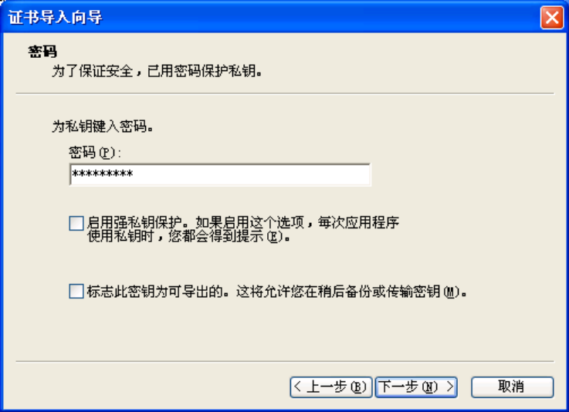
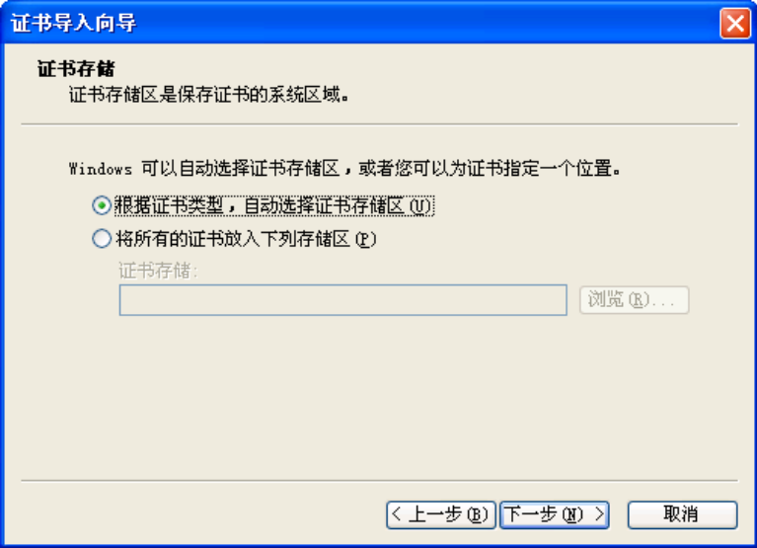
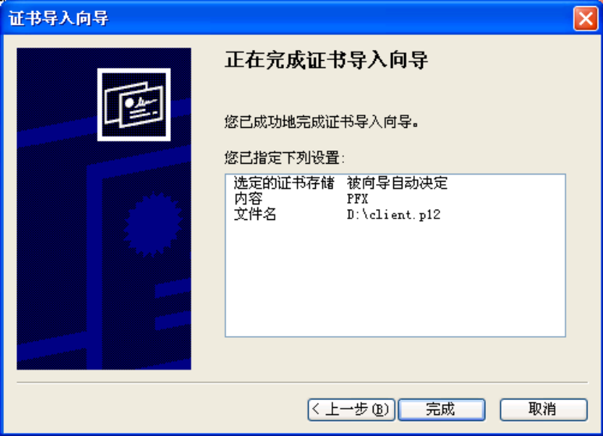
1.3 Accessing the Off-Book Trading Platform
1. After the installation of the certificate, input https://sim-obt.cffex.com.cn in a browser to access the Off-Book Trading Platform. In case of initial login, it is required to select a digital certificate, as shown below:
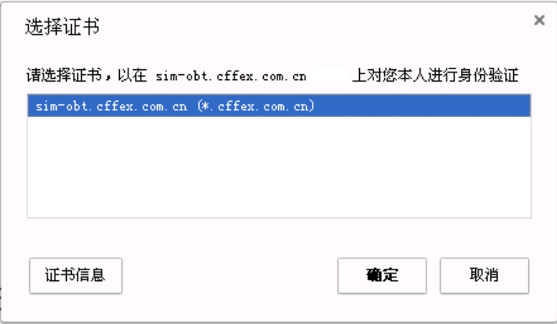
Given that the certificate is made by the Information Department of CEEFX, the browser might recognize it as unreliable, as shown below:
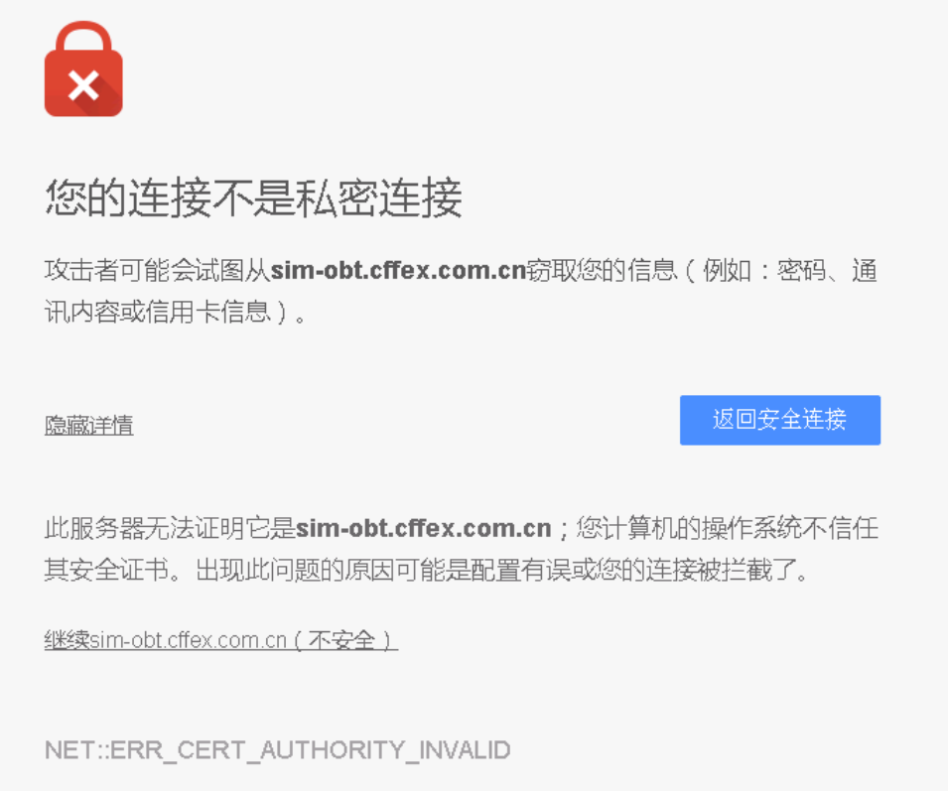
Click “Continue sim-obt.cffex.com.cn (Unsafe)” to open the home page of the Off-Book Trading Platform, as shown below:
