Operation Manual for User Management Related Functions of the Submission Software of the Off-Book Trading Platform for Financial Futures
Version V1.00

Chapter I Overview
As designed for new users of the System, this document provides an overview of and a quick start guide to the functions of the System for EFP transactions on Chinese government bond futures.
Chapter II describes the most basic operations of the System, including, but not limited to, how to log into and log out of the System and how to use the general functions of the interface.
Chapter III provides a detailed description of functions related to user management, including, inter alia, user management, role management and user group management.
Chapter IV mainly discusses functions for personal information and change of login passwords.
Note: Data in relevant screenshots provided herein is given as an example and for reference only.
Chapter II Basic Operations
2.1 Login
1. Insert a digital certificate into the USB port.
2. After entering the URL https://obt.cffex.com.cn in a browser, a certificate selection window will pop up (the following figure is for reference only).
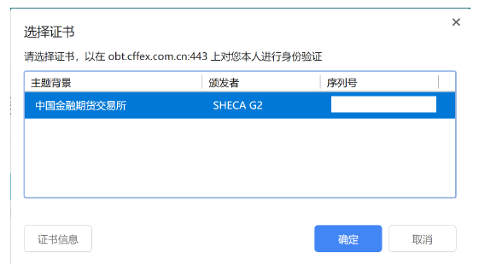
3. Select the corresponding digital certificate for EFP of CFFEX, click the “Confirm” button, and input the password of the digital certificate:
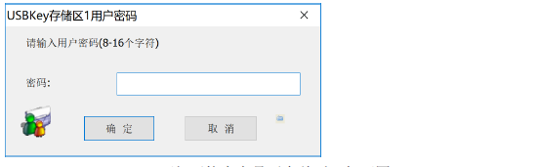
4. Open the home page of the Off-Book Trading Platform as shown below after the digital certificate is successfully validated:
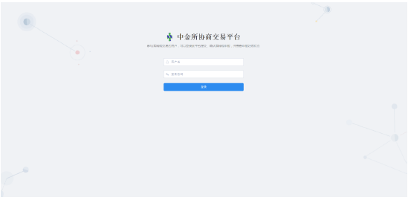
5. Input the user name and password and click the Login button. The System will verify whether the user name and password are correct and if correct, will give the prompt of “Successful Login”. Then, enter the System, as shown below:
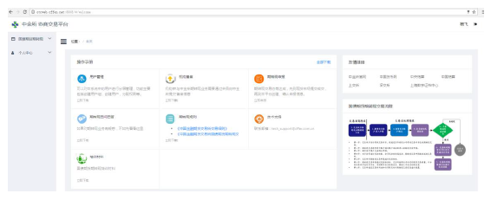
If the user name or password is incorrect, the System will give the prompt of “Incorrect User Name or Password”.
2.2. Logout
Click  next to the user name at the top right of the System’s page to view the “Logout” button. Click the “Logout” button, and the following confirmation dialog box will pop up:
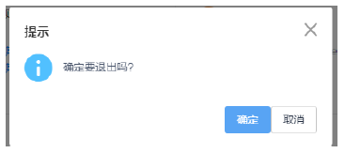
Click the “Confirm” button to log out of the System and the “Cancel” button to cancel the log-out operation and go back to the System.
2.3 Change Login Password
Description of Function:
After obtaining an account, an institution administrator should immediately change the initial login password. For security consideration, the institution administrator should change the password periodically.
Instructions:
1. Click the Personal Centre – Change Login Password to enter the “Change Login Password” page:
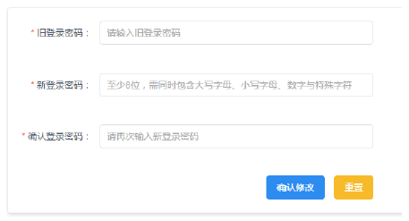
2. Input the old login password and new login password and confirm the new login password. The rule for setting of login passwords: a password should have at least 8 characters which contain upper case letters, lower case letters, numbers and special characters.
3. Click the “Confirm Change” button, and the System will pop up a confirmation dialog box for change of password as shown below. Click the “Confirm” button to submit the change of login password.
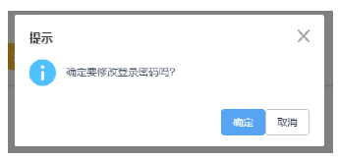
4. After the password is successfully changed, the System will jump to the login page for re-login.
2.4 User Information/ Personal Information
Description of Function:
A user can view his personal information and in case of any error therein, may contact his superior administrator to update the personal information.
Instructions:
Click the Personal Centre- User Information (or Personal Information) to enter the following page:
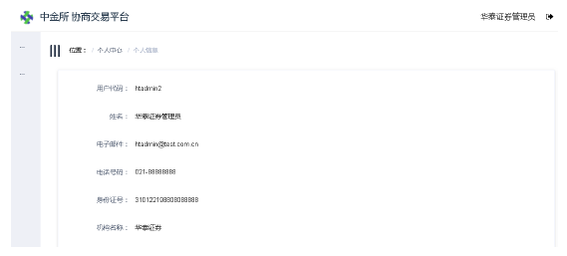
Chapter III User Management
This part mainly describes user group management, role management and user management. Before engaging in off-book trading business at CFFEX, an institution is required to submit a registration application to CFFEX via its carrying member. Upon approval of the application, CFFEX will create a user group and an administrator account of the user group for the institution. Then, the account will be delivered to the institution via the carrying member. The institution should communicate with its carrying member with respect to the submission of registration materials, the methods of obtaining relevant materials upon approval of the registration and the contact persons.
An institution administrator should use the obtained account information to log into the System to manage the information and operation permissions of the institution’s users who are involved in off-book trading business.
Generally, if the tiered management of users are not required, the institution administrator can complete the management of user information by simply creating users and assigning permissions (or roles) to them after logging into the System by using the obtained account, i.e., the simplest operation of user management is as follows:
Create users – Assign permissions (or roles) to users.
3.1 User Management
User information management includes creation of users, assignment of permissions to users, and other operations with respect to user information.
3.1.1 Query
Description of Function:
This function is intended to query about user information.
Instructions:
1. Click on the menu to enter the " User Information List" function interface as shown below:
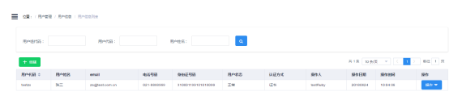
3.1.2 Create
Description of Function:
This function is intended to create user information.
Instructions:
1. Click the “Create” button to enter the “New User” interface:
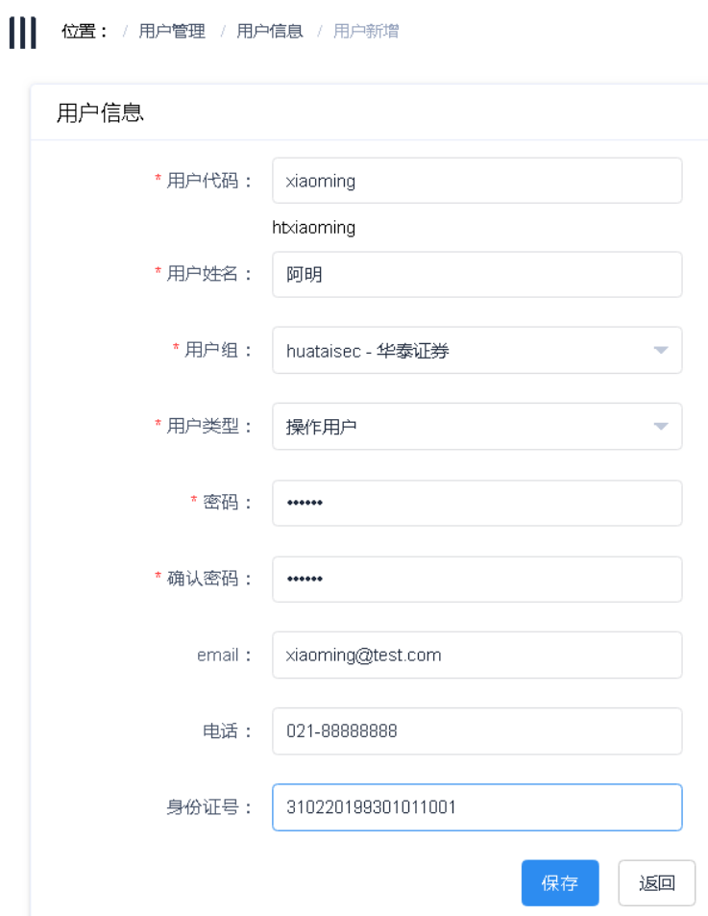
a. User code: input a user code. A prefix representing the institution’s user group will be added before the code input to distinguish the user code. And the final user code will be displayed below the input area. User codes from a single institution cannot be identical.
b. Continue to input another user information. Information such as the user’ password, email, telephone and ID card number will be encrypted and stored by the System.
2. Click the “Save” button, and the System will give the prompt of “Successfully Submitted” upon successful verification and in case of unsuccessful verification, will return a corresponding error message.
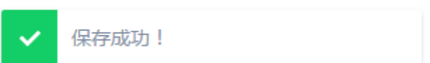
3. Click the “Return” button to return to the query submission interface.
3.1.3 Assign Roles
Description of Function:
This function is intended to assign roles to users. One user may be assigned multiple roles and ultimately have the combined roles of those roles
Instructions:
1. Click the “Operation” button corresponding to the record of a user. Operational functions will be displayed as follows:
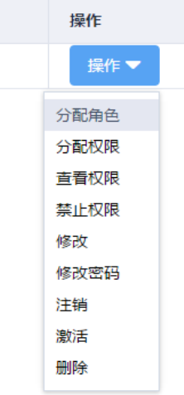
2. Click the “Assign Roles” function to enter the “Assign Role(s) to User” function page. By default, no role will be found:
a. Select a user group. The user group to which the current user belongs and any sub-user groups created by such user are available for selection. The table of un-assigned roles will load roles under the user group that may be assigned to the current user.
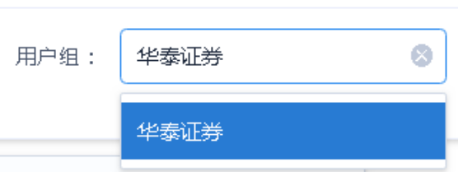
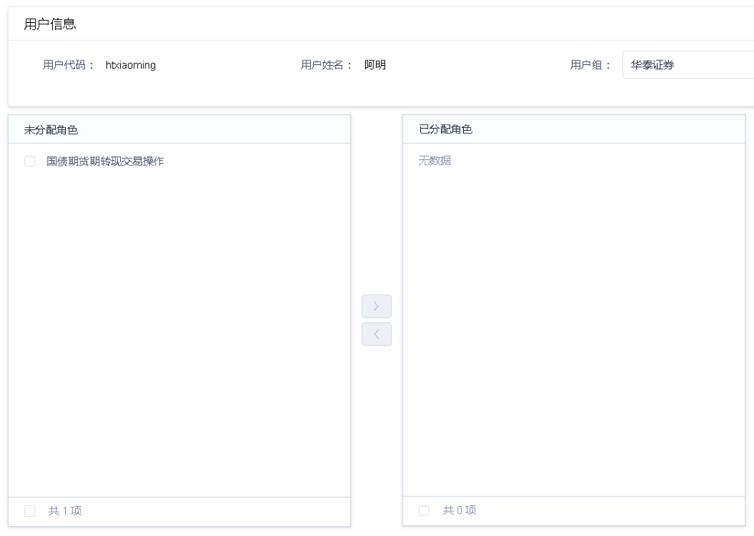
b. Tick any role to be assigned to such user.
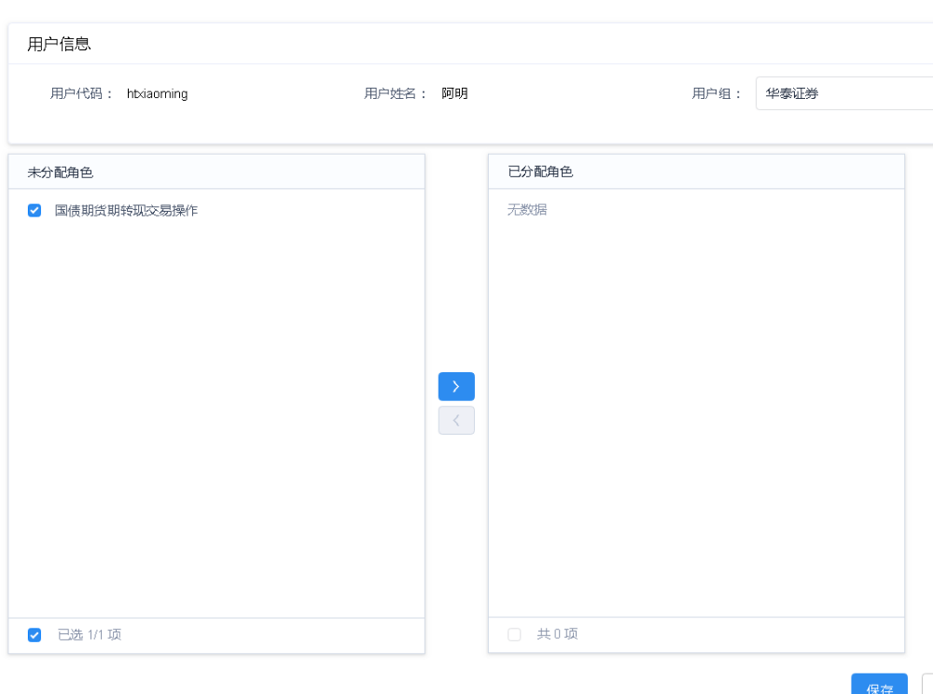
c. Click  to assign the role to the current user.
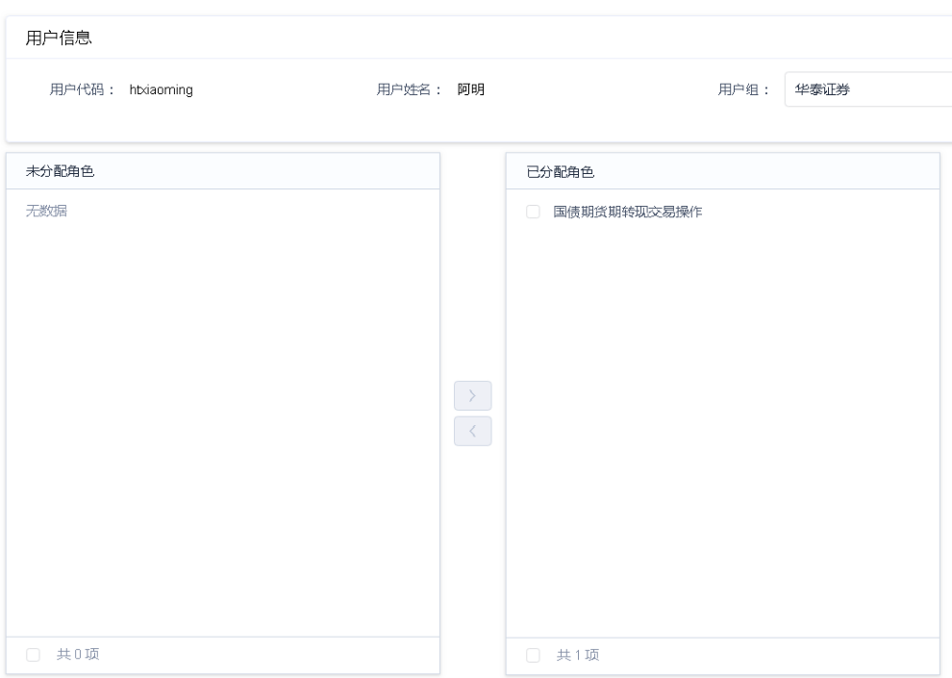
3. Click the “Save” button, and the System will give the prompt of “Successfully Saved” upon successful verification and in case of unsuccessful verification, will return a corresponding error message.
4. Click the “Return” button to return to the main interface for user management.
3.1.4 Assign Permissions
Description of Function:
If unique permissions are required to be assigned to a specific user, this function can be used to do so. The assignment of permissions is independent of that of roles. The permissions of a user are a combination of those of its roles and those separately assigned to it.
Instructions:
1. Click the “Operations” button corresponding to the record of a user to whom permissions are to be assigned. The operational functions will be displayed as follows:
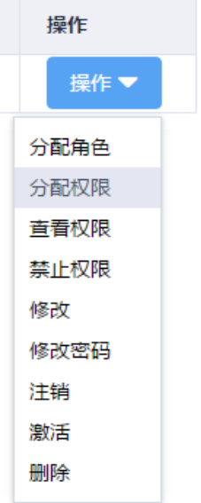
2. Click the “Assign Permissions” function to enter the “Assign Permissions to User” function page:
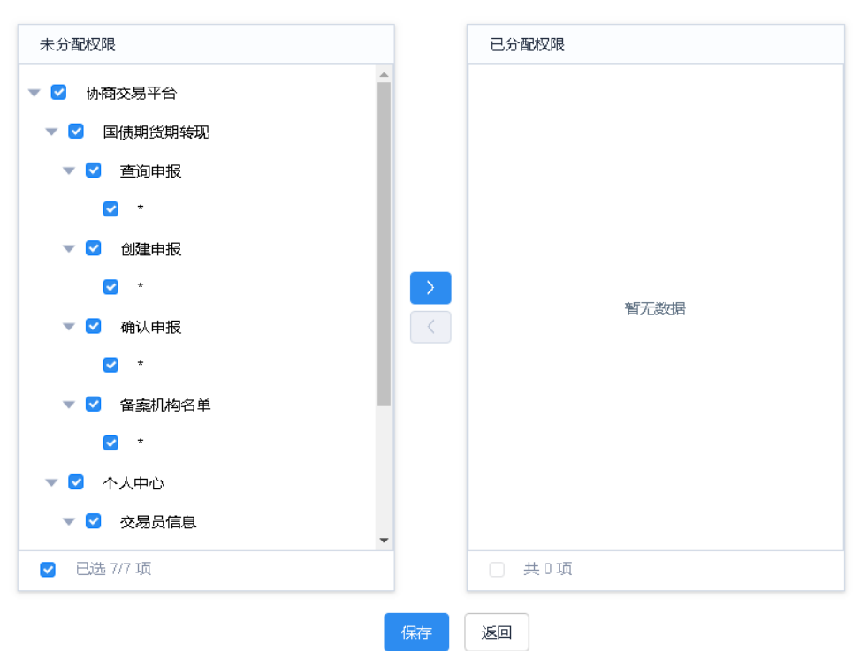
3. Single out permissions to be assigned to the user and after the completion of the assignment, click the “Save” button. The System will give the prompt of “Successfully Saved” upon successful verification and in case of unsuccessful verification, will return a corresponding error message.
4. Click the “Return” button to return to the main interface for user management.
3.1.5 View Permissions
Description of Function:
This function is intended to view the permissions of a specific user, including the permissions of roles assigned to it and permissions separately assigned to it and excluding its disabled permissions.
Instructions:
1. Click the “Operations” button corresponding to the record of a user whose permissions are to be viewed to display operational functions as follows:
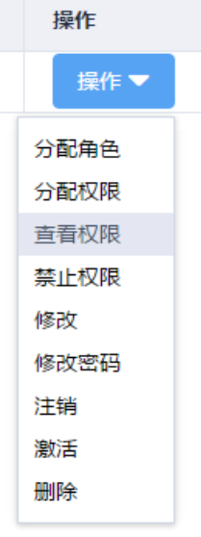
2. Click the “View Permissions” function to enter the “User Permission Details” function page where all menu permission functions of the current user can be viewed. “All functions” mean all operating functions under the corresponding menu.
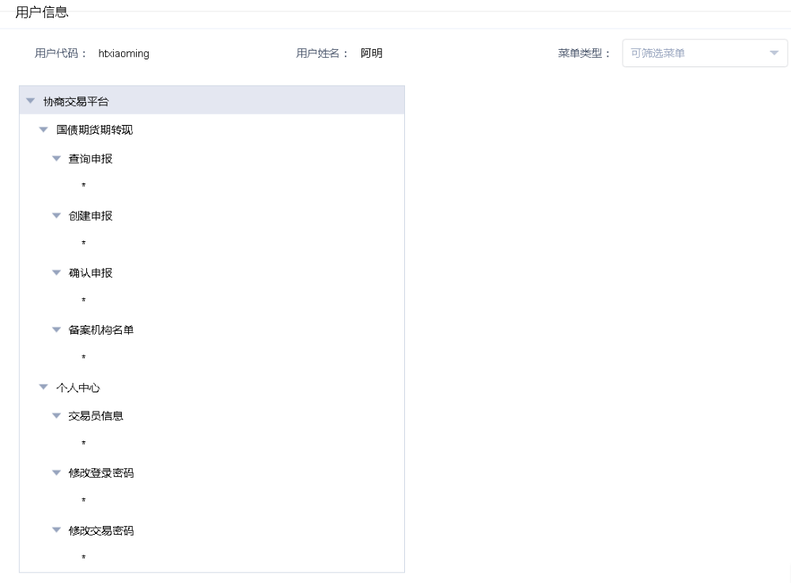
3. Click the “Return” button to return to the main interface for user management.
3.1.6 Disable Permissions
Description of Function:
If certain permissions of a specific user are required to be disabled, this function can be used to do so. The user’s menus will not include those corresponding permissions once the permissions are disabled.
Instructions:
1. Click the “Operations” button corresponding to the record of a user whose permissions are to be disabled to display operational functions as follows:
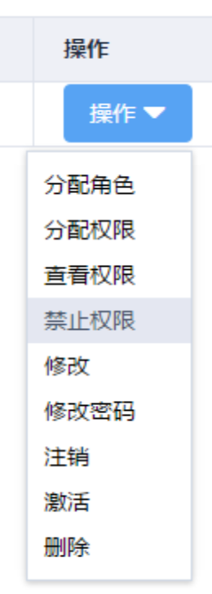
2. Click the “Disable Permissions” function to enter the “Disable User Permissions” function page:
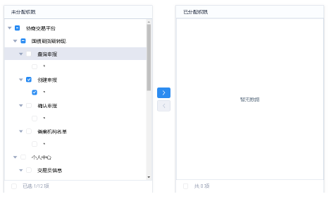
3. Single out any permission to be disabled for the user and after the completion of the disabling operation, click the “Save” button. The System will give the prompt of “Successfully Saved” upon successful verification and in case of unsuccessful verification, will return a corresponding error message.
4. Click the “Return” button to return to the main interface for user management.
3.1.7 Modify
Description of Function:
This function is intended to modify user information.
Instructions:
1. Click the “Operations” button corresponding to the record of a user whose information is to be modified to display operational functions as follows:
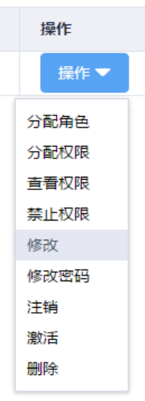
2. Click the “Modify” function to enter the “Modify User Information” function page, as shown below, where the information of a selected user can be modified:
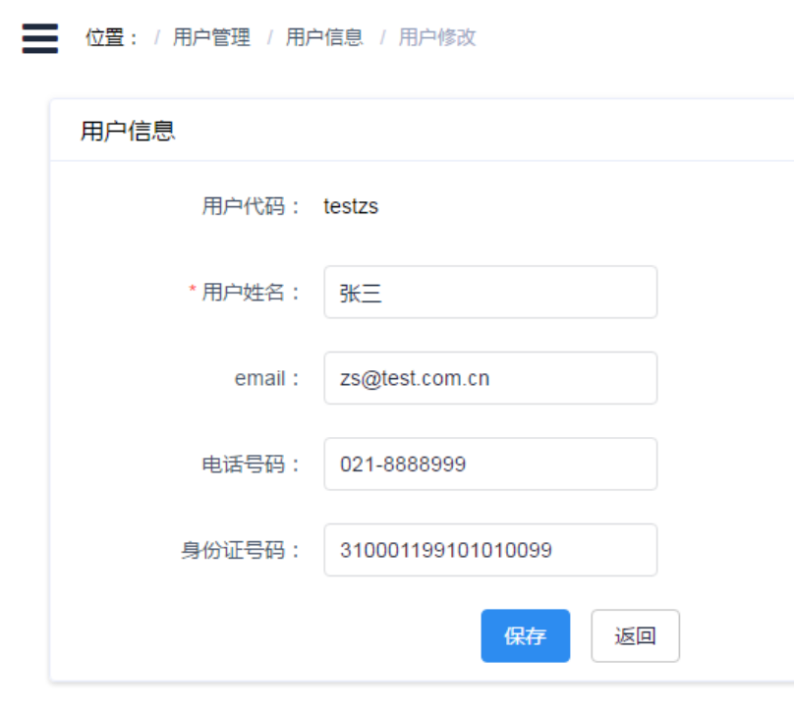
3. Modify user information and click the “Save” button to save the modified user information. Click the “Return” button to return to the main interface for user management.
3.1.8 Change Password
Description of Function:
If a user reports that it has forgotten its password, the administrator may change the user password for the user.
Instructions:
1. Click the “Operations” button corresponding to the record of a user whose password is to be changed to display operational functions as follows:
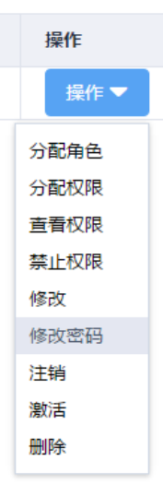
2. Click the “Change Password” function to enter the “Change Password” function page, as shown below, where the password of a specified user can be changed:
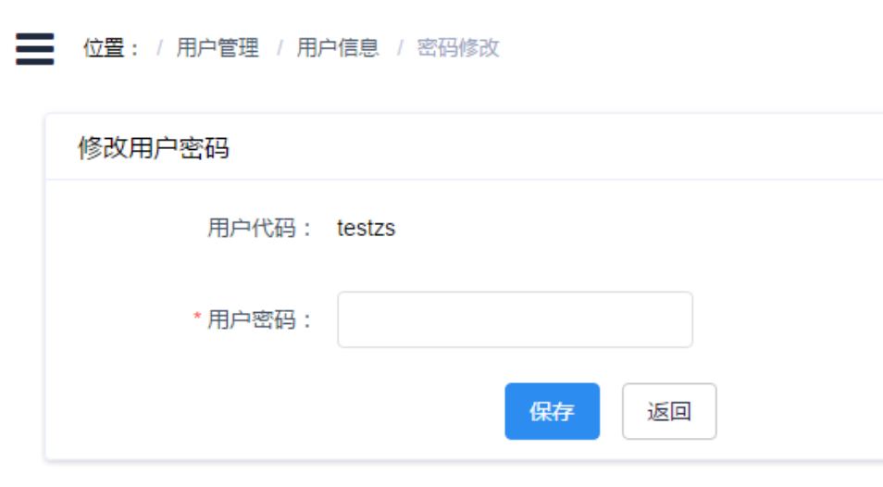
3. Input the new password and click the “Save” button to save the user’s new password. Click the “Return” button to return to the main interface for user management.
3.1.9 Cancel
Description of Function:
This function is intended to cancel accounts. Upon being cancelled, an account cannot be used to log into the System.
Instructions:
1. Click the “Operations” button corresponding to the record of a user whose account is to be cancelled to display operational functions as follows:
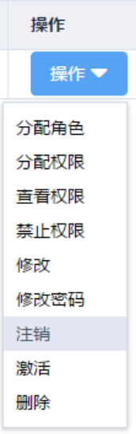
2. Click the “Cancel” function to cancel the user’s account, and the System will give the prompt of “Successfully Cancelled”:
3. After the cancelation of the user’s account, the status of the user will be changed to “Cancelled” as shown below:
3.1.10 Activate
Description of Function:
This function is intended to activate cancelled accounts. Upon being activated, a cancelled account can continue to be used to log into the System.
Instructions:
1. Click the “Operations” button corresponding to the record of a user whose account is to be activated to display operational functions as follows:
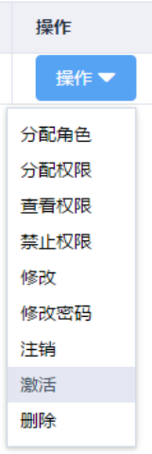
2. Click the “Activate” function to activate the user’s account, and the System will give the prompt of “Successfully Activated”.
3. After the activation of the user’s account, the status of the user will be changed to “Normal” as shown below:
3.1.11 Delete
Description of Function:
This function is intended to delete users.
Instructions:
1. Click the “Operations” button corresponding to the record of a user to be deleted to display operational functions as follows:
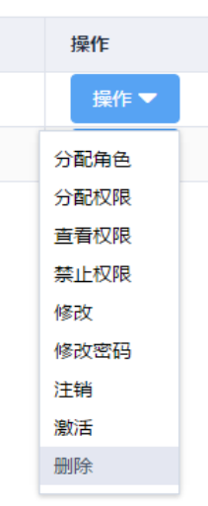
2. Click the “Delete” function, and a confirmation dialog box for deletion of the user will pop up.
3. Click the “Confirm” button, and the System will delete the user upon successful verification and in case of unsuccessful verification, will return a corresponding error message.
3.2 Role Management
After creating users, an institution administrator needs to assign permissions to them. If many users require the same scope of permissions, the administrator may first create a role and assign permissions to such role to access the corresponding operating menus. In this way, after creating users, the administrator just needs to assign such role to them instead of selecting the menu permission record for each user, which can improve the efficiency of assigning permissions to the users.
A role can be understood to be a combination of some menu permissions.
3.2.1 Query
Description of Function:
This function is intended to query about role information.
Instructions:
1. Click on the menu to enter the “Role Information List” function interface. If there is no role when an institutional user administrator initially logs into the interface, the following will be displayed:
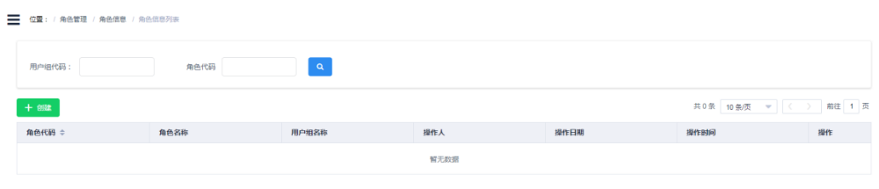
2. If any role has been set, the following will be displayed:
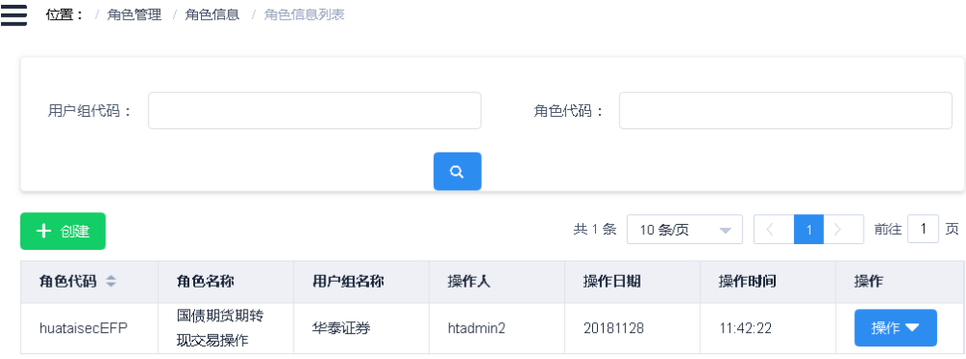
3.2.2 Create
Description of Function:
This function is intended to create role information.
Instructions:
1. Click the “Create” button to enter the “New Role Information” interface:
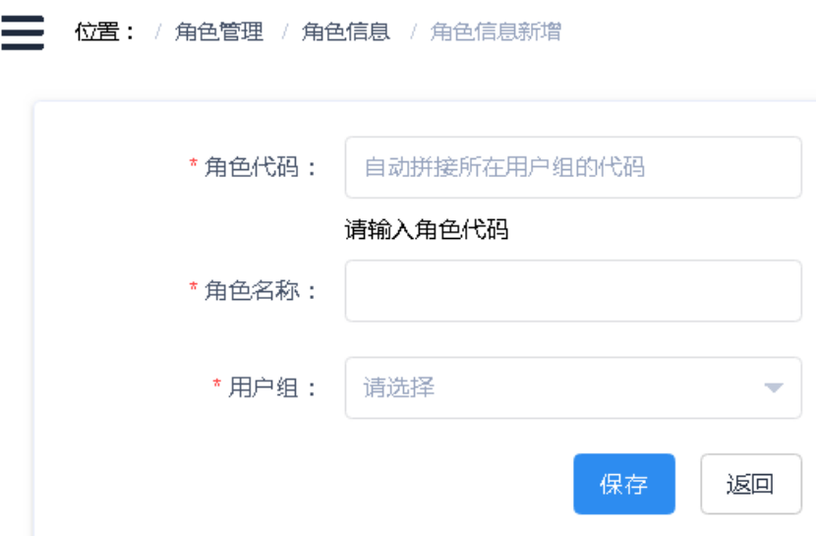
a. Role code: input a role code. The code of a selected user group will be added before the code input to distinguish the role code. And the final user code will be displayed below the input area (subject to an update after the selection of the user group). Role codes from a single institution cannot be identical.
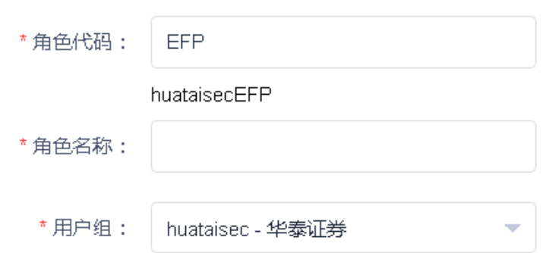
b. Role name: design an easy-to-understand name for this role so that the usage of this role can be understood quickly when multiple roles are created:
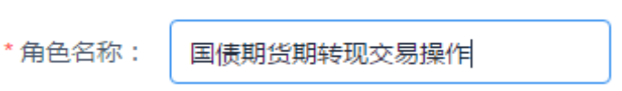
c. User group: select the user group to which the role belongs. The drop-down list will display the user group in which the current user is and any user group created by such user.
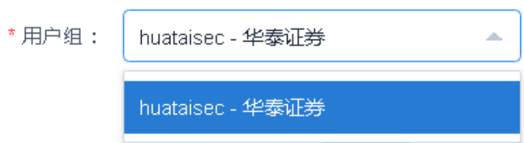
2. Click the “Save” button, and the System will give the prompt of “Successfully Submitted” upon successful verification and in case of unsuccessful verification, will return a corresponding error message.
3. Click the “Return” button to return to the query submission interface.
3.2.3 Assign Permissions
Description of Function:
This function is intended to assign permissions to roles.
Instructions:
1. Click the “Operations” button corresponding to the record of a role to whom permissions are to be assigned to display operational functions as follows:
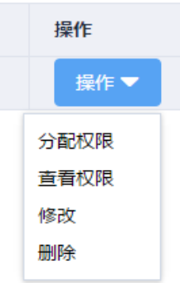
2. Click the “Assign Permissions” function to enter the “Assign Permissions to Role” function page:
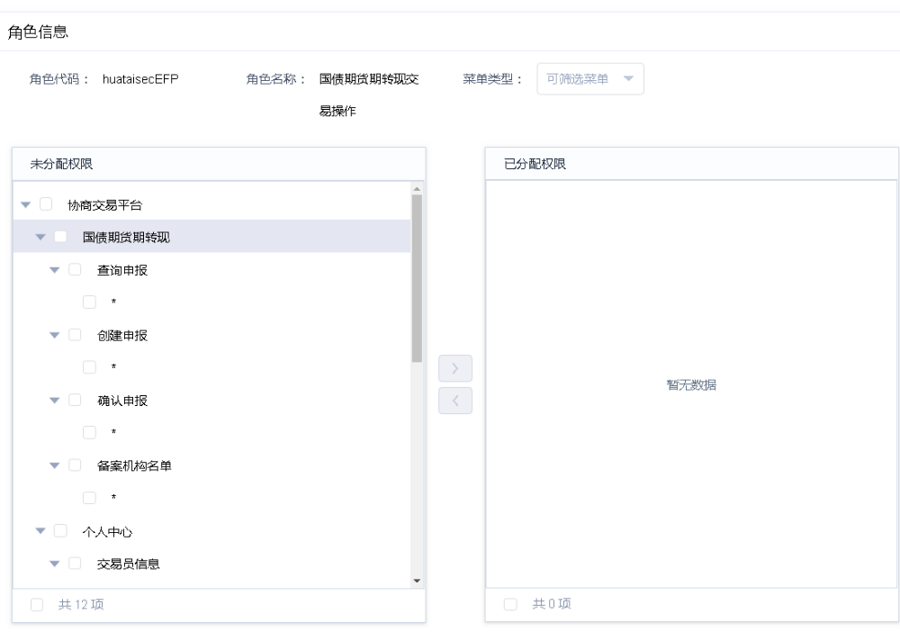
a. Role code: the code of the role that is the subject of this operation will be displayed.
b. Role name: the name of the role that is the subject of this operation will be displayed.
c. Menu type: as shown in the figure below, “Management Menu” and “Operation Menu” are available for selection. The former mainly includes three menus for user management: user group management, role management and user management. The latter mainly includes permissions for such operations as creating and confirming EFP reports (subject to the actual functions of the System). If no selection is made, all permissions available in the System can be assigned to the role.
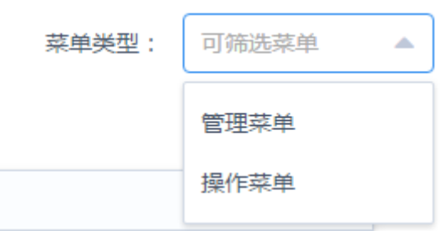
3. As shown in the figure below, select any permissions to be assigned to the current role:
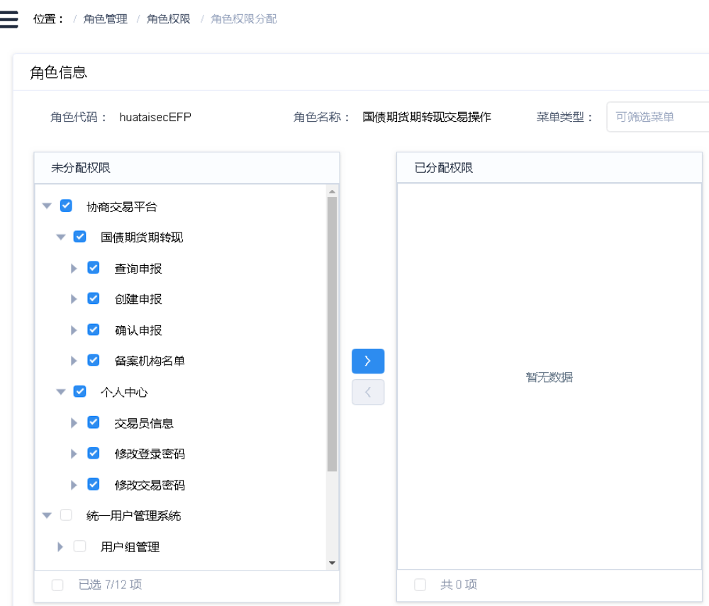
4. Click the  button to add the selected permissions to the list of “Assigned Permissions” as shown below:
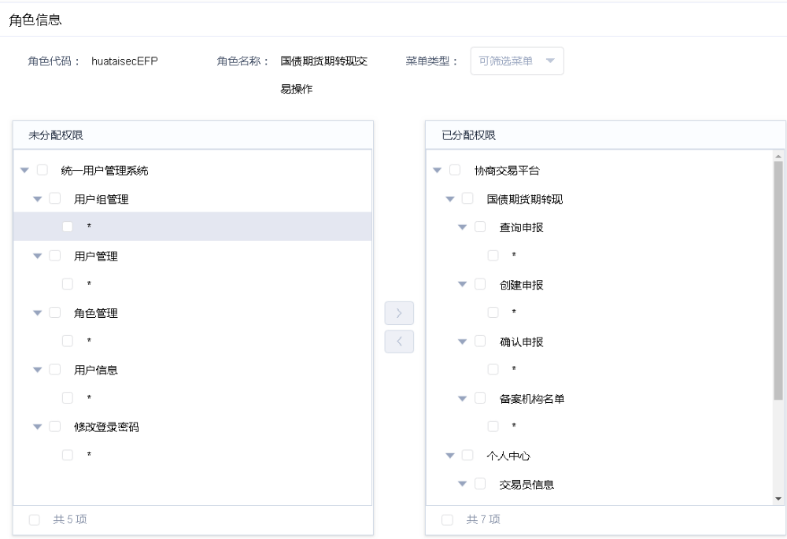
5. Click the “Save” button, and the System will give the prompt of “Successfully Saved” upon successful verification and in case of unsuccessful verification, will return a corresponding error message.
6. Click the “Return” button to return to the main interface for role management.
3.2.4 View Permissions
Description of Function:
This function is intended to view menu permissions assigned to roles.
Instructions:
1. Click the “Operations” button corresponding to the record of a role whose permissions are to be viewed to display operational functions as follows:
2. Click the “View Permissions” function to enter the “Role Permission Details” function page where all menu permission functions of the current role can be viewed. “All functions” mean all operating functions under the corresponding menu.
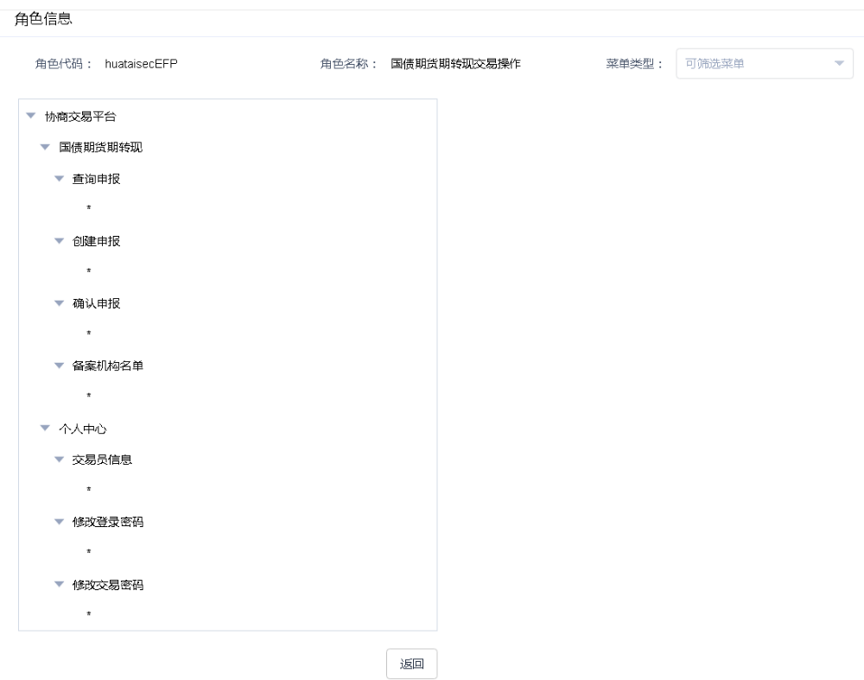
3. Click the “Return” button to return to the main interface for role management.
3.2.5 Modify
Description of Function:
This function is intended to modify role information.
Instructions:
1. Click the “Operations” button corresponding to the record of a role whose information is to be modified to display operational functions as follows:
2. Click the “Modify” function to enter the “Modify Role Information” function page, as shown below, where the role name can be modified:
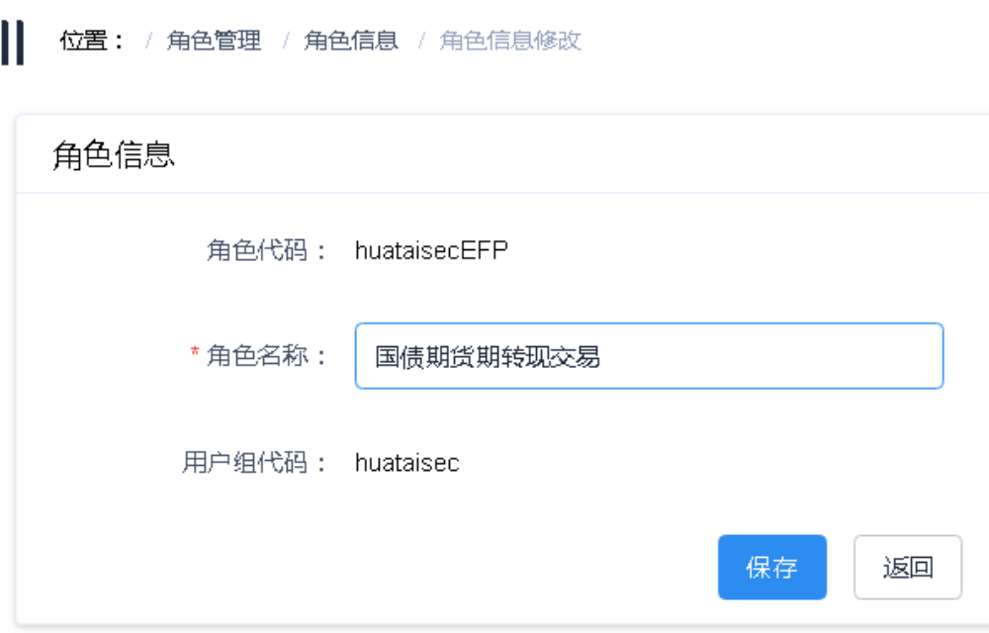
3. Click “Save” to save the modified role name, and click the “Return” button to return to the main interface for role management.
3.2.6 Delete
Description of Function:
This function is intended to delete roles.
Instructions:
1. Click the “Operations” button corresponding to the record of a role to be deleted to display operational functions as follows:
2. Click the “Delete” function, and a confirmation dialog box for deletion of the role will pop up.
3. The System will delete the role if it verifies that the role is out of use; and will prompt a corresponding error message if not.
3.3 User Group Management
A current user may create sub-user groups if necessary. For example, the institution administrator of a securities company may create asset management, fixed income and other user groups based on its needs for internal control and set up an administrator for each group to carry out tiered management.
Of course, an institution may also manage users in a completely flat structure, that is, all users are directly managed by an institution administrator, in which case, it is not necessary to maintain user group information.
3.3.1 Query
Description of Function:
This function is intended to query about user group information.
Instructions:
2. Click on the menu to enter the “User Group Information List” function interface. When an institutional user administrator logs into the interface for the first time, the information displayed is the user group information created by CFFEX for the institution:
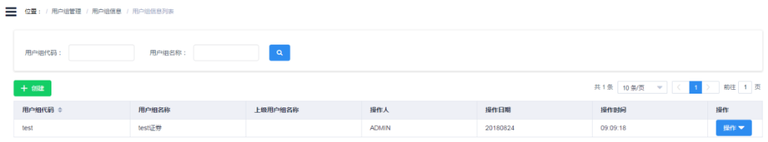
3. If the current user has created other user groups, it can manage them through this function.
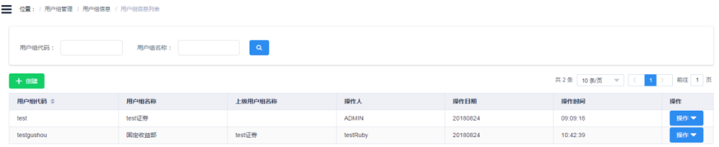
3.3.2 Create
Description of Function:
This function is intended to create user group information.
Instructions:
1. Click the “Create” button to enter the “New User Group Information” interface:
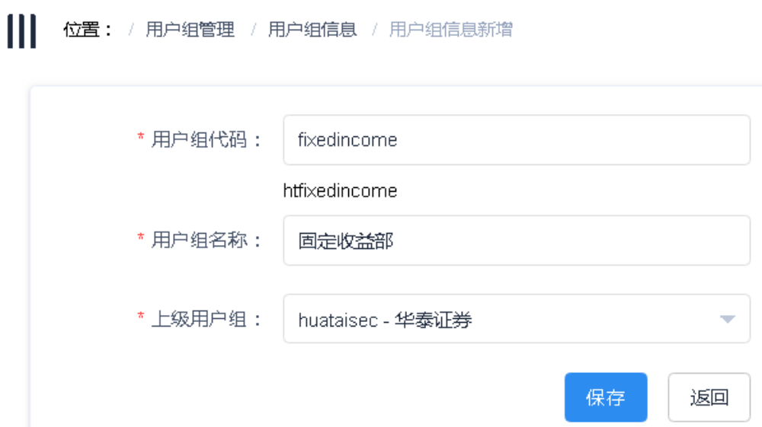
a. User group code: input a user group code. The user group code will ultimately be preceded by a prefix representing the institution. User codes from a single institution cannot be identical.
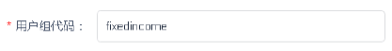
b. User group name: the name of a department or subsidiary is recommended to be set as the user group name based on the institution’s internal control requirements.
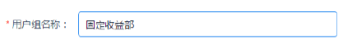
c. Superior user groups: user groups that can be selected in the drop-down list are superior user groups for the current user.
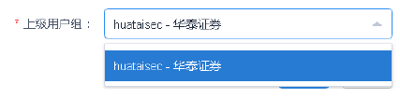
2. Click the “Save” button, and the System will give the prompt of “Successfully Submitted” upon successful verification and in case of unsuccessful verification, will return a corresponding error message.
3. Click the “Return” button to return to the query submission interface.
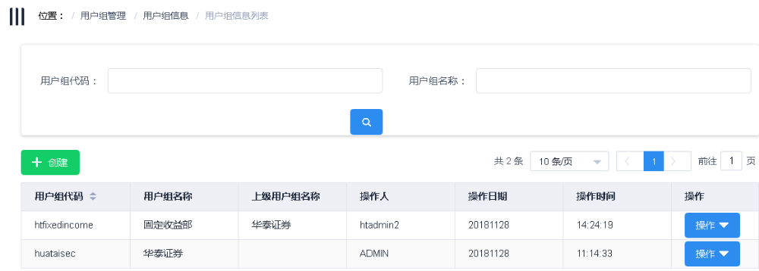
3.3.3 Assign Roles
Description of Function:
This function is intended to assign roles to user groups. A user group may be assigned multiple roles and ultimately have combined permissions of those roles.
Instructions:
1. Click the “Operations” button corresponding to the record of a user group to whom roles are to be assigned to display operational functions as follows:
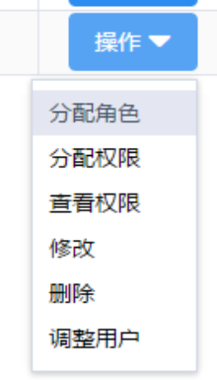
2. Click the “Assign Roles” function to enter the “Assign Roles to User Group” function page. By default, all roles that can be assigned will be found:
a. Tick any role to be assigned to the user group.
b. Click to assign the role to this user group.
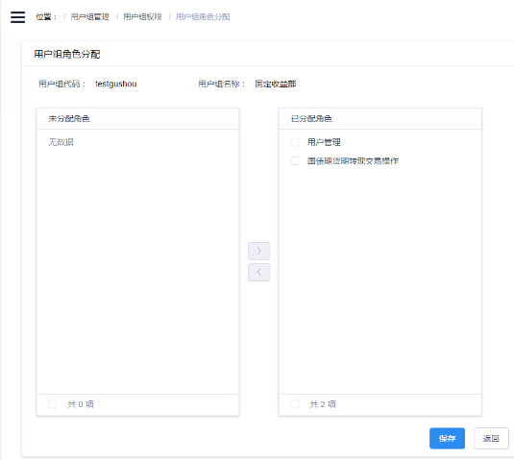
3. Click the “Save” button, and the System will give the prompt of “Successfully Saved” upon successful verification and in case of unsuccessful verification, will return a corresponding error message.
4. Click the “Return” button to return to the main interface for user group management.
3.3.4 Assign Permissions
Description of Function:
If unique permissions are required to be assigned to a specific user group, this function can be used to do so. The assignment of permissions is independent of that of roles. The permissions of a user group are a combination of those of its roles and those separately assigned to it.
Instructions:
1. Click the “Operations” button corresponding to the record of a user group to whom permissions are to be assigned to display operational functions as follows:
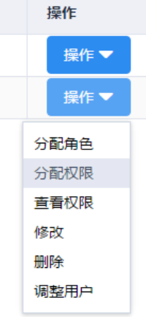
2. Click the “Assign Permissions” function to enter the “Assign Permissions to User Group” function page. By default, the System will assign menu permissions for user management to the created user group, because each user group has its own administrator who must have permissions for user management.
3. Tick any permissions to be assigned to the user group and after the completion of the assignment, click the “Save” button. The System will give the prompt of “Successfully Saved” upon successful verification and in case of unsuccessful verification, will return a corresponding error message.
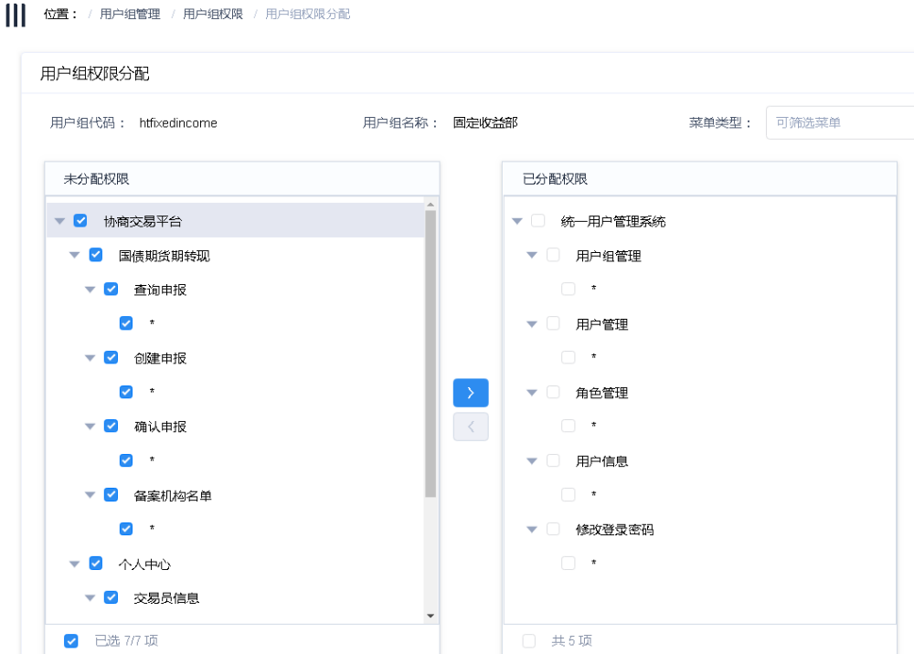
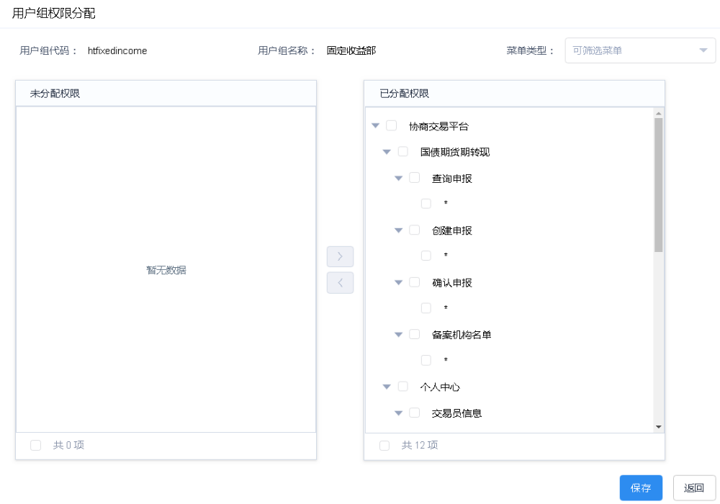
4. Click the “Return” button to return to the main interface for user group management.
3.3.5 View Permissions
Description of Function:
This function is intended to view the permissions of a specific user group, including the permissions of roles assigned to it and permissions separately assigned to it.
Instructions:
1. Click the “Operations” button corresponding to the record of a user group whose permissions are to be viewed to display operational functions as follows:
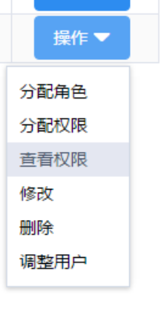
2. Click the “View Permissions” function to enter the “User Group Permission Details” function page where all menu permission functions of a selected user group can be viewed. “All functions” mean all operating functions under the corresponding menu.
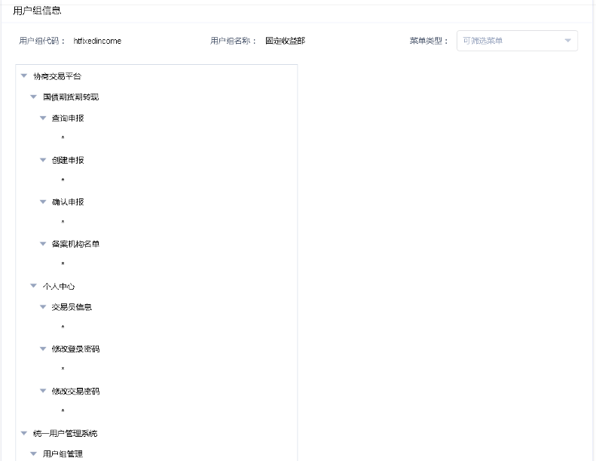
3. Click the “Return” button to return to the main interface for user group management.
3.3.6 Modify
Description of Function:
This function is intended to modify user group information.
Instructions:
1. Click the “Operations” button corresponding to the record of a user group whose information is to be modified to display operational functions as follows:
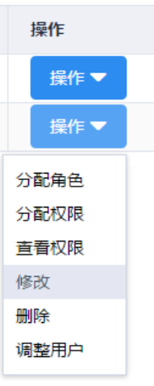
2. Click the “Modify” function to enter the “Modify User Group Information” function page, as shown below, where the name of a selected user group can be modified:
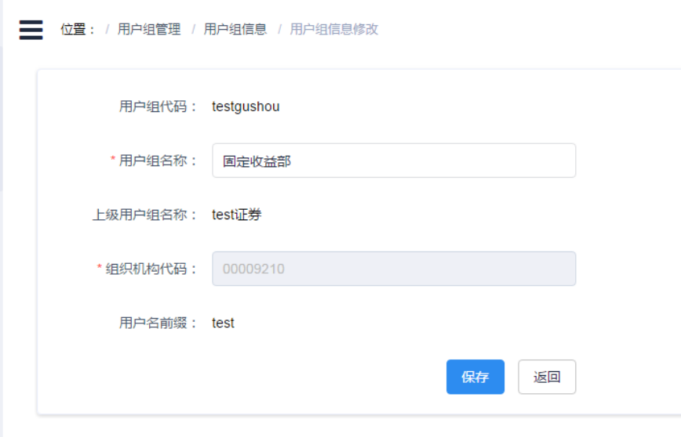
3. Modify the user group information, click “Save” to save the modified user group information, and click the “Return” button to return to the main interface for user group management.
3.3.7 Delete
Description of Function:
This function is intended to delete user groups. Any user group under which there are users or other sub-user groups cannot be deleted.
Instructions:
1. Click the “Operations” button corresponding to the record of a user group to be deleted to display operation functions as follows:
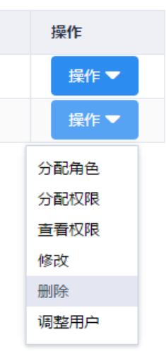
2. Click the “Delete” function, and a confirmation dialog box for deletion of the user group will pop up.
3. Click the “Confirm” button. The System will delete the user group upon successful verification; and will prompt a corresponding error message in case of unsuccessful verification.
3.3.8 Adjust Users
Description of Function:
This function can be used to adjust user information of user groups, i.e. to adjust a user from Group A to Group B, or to add a user to Group B.
Instructions:
1. Click the “Operations” button corresponding to the record of a user group whose users are to be adjusted to display operational functions as follows:
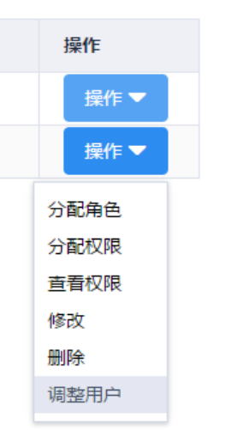
2. Click the “Adjust Users” function to enter the “User Group User Settings” function page:
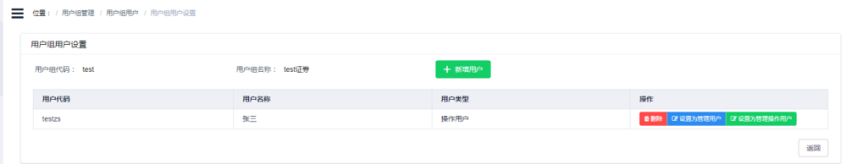
a. User group code: the code of the user group that is the subject of this operation will be displayed.
b. User group name: the name of the user group that is the subject of this operation will be displayed.
c. Users of the current user group will be displayed in the table.
3. Click the “New User” button, and a “Select User” dialog box will pop up, displaying other users of the user group in which the currently logged-in user is and users of any sub-user groups created by the current user.
4. As shown in the figure below, select any users to be added to the current user group:
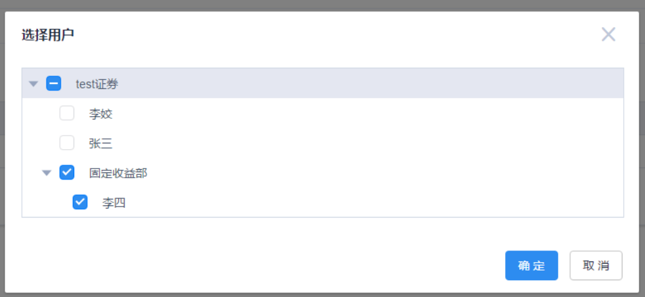
5. Click the “Confirm” button to add the selected permissions to the current user group as shown below:
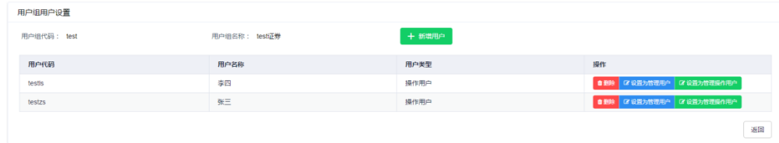
6. Click the “Delete” button to remove a user out of the current user group without deleting the user.
7. Click the “Set as Admin User” button to set an “Operating User” or “Operating Admin User” as an administrator, in which case, operating permissions originally granted to the user will be deleted, and menu permissions for user management, user group management and role management will be automatically added to the user’s permissions. After the completion of the setting, the user type will also be changed:
8. Click the “Set as Operating User” button to set an “Admin User” or “Operating Admin User” as an operating user, in which case, the user’s original management permissions will be deleted, with its original operating permissions remaining unchanged.
9. Click the “Set as Operating Admin User” button to set an “Admin User” or “Operating User” as an operating admin user, in which case, all management permissions will be added to the user’s permissions, with its original operating permissions remaining unchanged.
10. Click the “Return” button to return to the main interface for user group management.

