Installation Guide for Support Software Related to SHECA Digital Certificate
The following description is provided according to the recommendations of SHECA. If there is any inconsistency with such description in practice, the description of SHECA will prevail.
The contact information of SHECA is as follows:
Fax: 021-36393132 Service hotline: 021-962600
Email: jy@sheca.com Website: http://www.sheca.com
SHECA’s customer service specialist who provides support for the processing of SHECA digital certificates for EFP of CFFEX is Chen Jie available at 021-36393130
- ShecAid
Input https://www.sheca.com/resources/tools in a browser to enter the “Download Centre” of SHECA, and download ShecAid from the “Software & Driver Download” section by downloading the ShecAid.zip file.
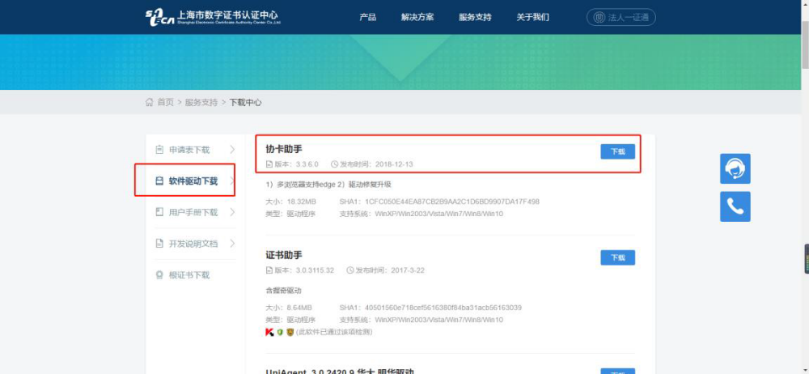
- Unzip the zip package and double-click ShecAid.exe to start the installation. The ShecAid should be installed on the device where the digital certificate needs to be inserted.

- If the “User Account Control” box pops up, prompting: “Do you allow this app to make changes to your device?”, please select “Yes”.
- Enter the installation page.

- Click “Custom Installation” and select an installation path.

- Click “Install Now” to start the installation.
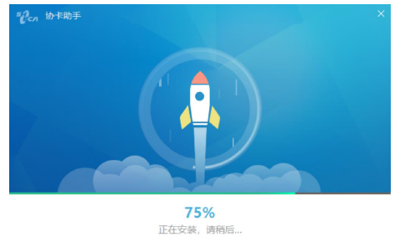
- When the installation is completed, click “Run Now”.
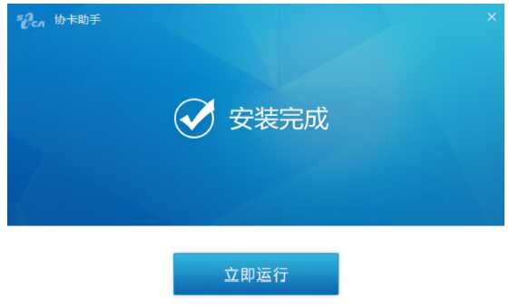
- Double-click the ShecAid icon in the “Status Bar” to open its main page.
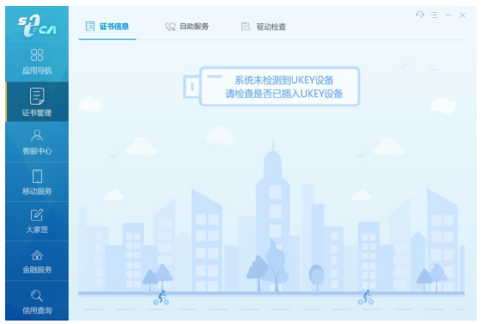
- Insert the certificate carrier to view relevant information of the certificate.
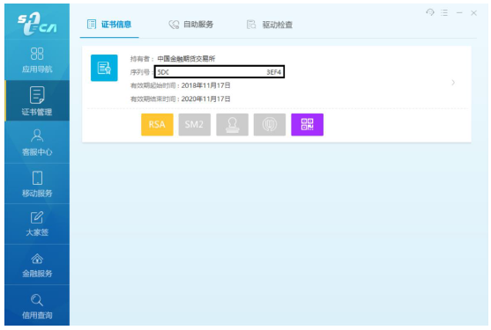
- Click “RSA” to view the certificate information. Find “User” to examine whether the value of the OU field (which should be an organization code) is correct.
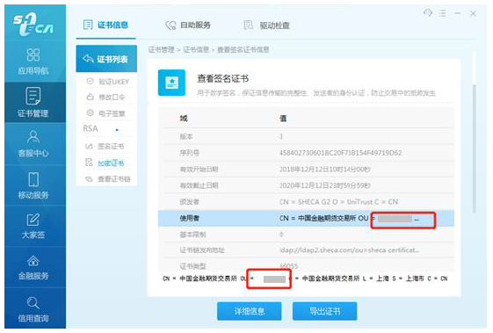
II. Root Certificate
- Click the “Root Certificate Download” section.
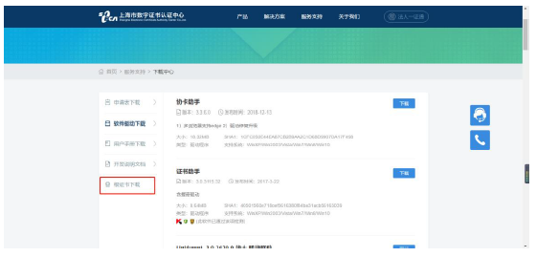
- Enter the CA certificate page and download the UCA_Root_G2 certificate.
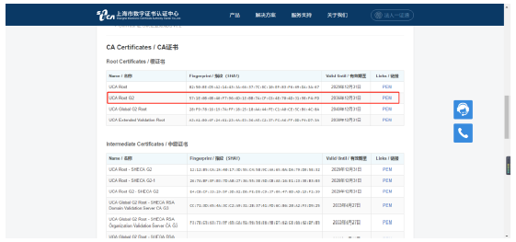
- Double-click the downloaded file as shown below to start the installation of the certificate. The root certificate should be installed on the device where the digital certificate needs to be inserted.
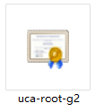
- Follow the following steps to install the root certificate.
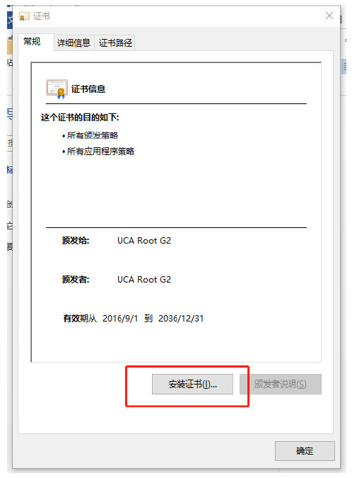
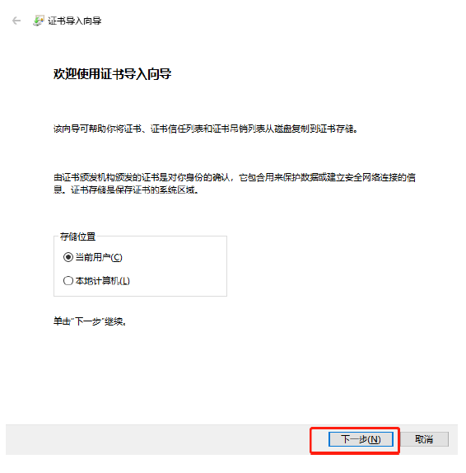
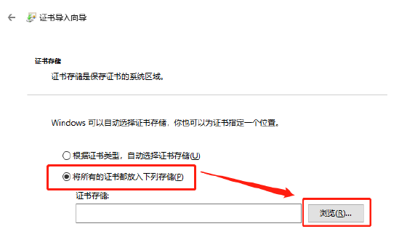
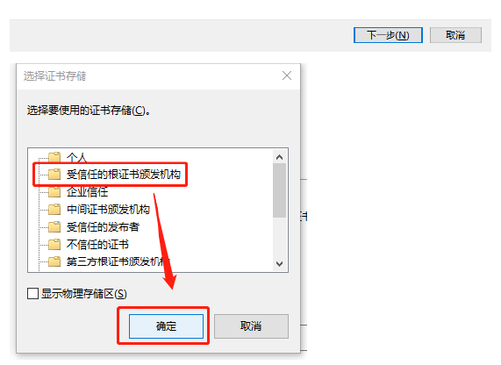
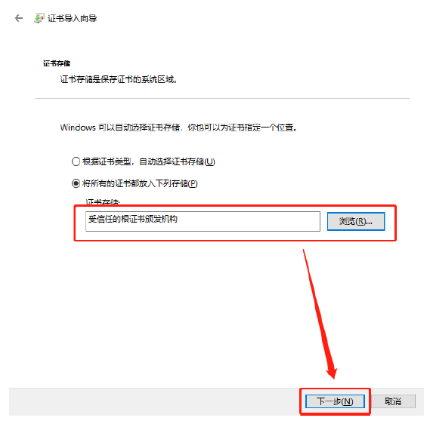
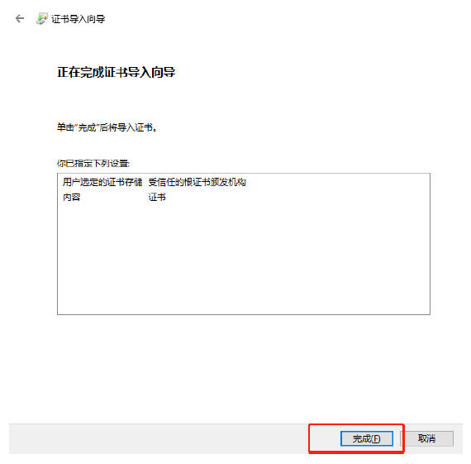
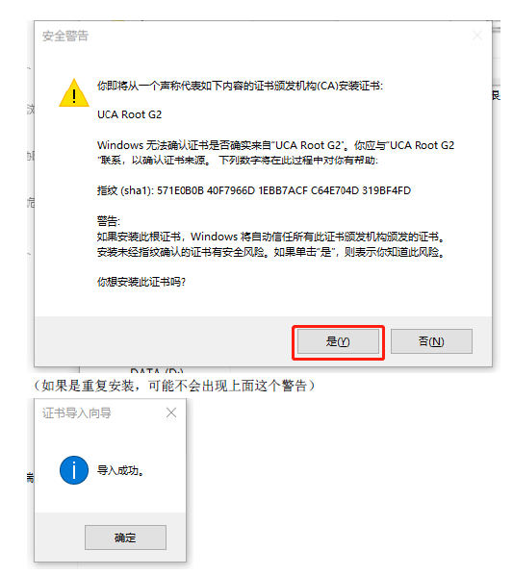
- When the installation is completed, view the detailed information of the digital certificate in the ShecAid. If the certificate path is shown as follows, it means that the certificate has been successfully installed:
