Instructions
for
Handling and Testing of the Member Circuit Service


February 24, 2011

Contents
Chapter 1 General Provisions 1
Chapter 2 Procedures for Circuit Accessing 2
Chapter 3 Procedures for Circuit Cancelling 4
Chapter 4 Procedures for Circuit Changing 6
Chapter 5 Communication Circuit Interruption and Network Change Reporting 8
Chapter 6 Suggestions on Circuit Testing 10
6.1 Test Environment Preparation 10
6.2 Test Plan 10

Chapter 1 General Provisions
The dedicated member network (“the network”) of China Financial Futures Exchange (“the Exchange”) is a special network for members to access the Exchange, conduct businesses including those related to financial futures trading, clearing, and market information. The network is an essential part of the financial futures information system and an important supporting platform for the financial futures business.
According to the CFFEX Management Guidelines for the Dedicated Member Network, to ensure safe, stable and reliable operation of the IT systems, regulate members’ accessing and using of the network, and enhance member’s understanding of procedures and requirements related, the Exchange compiles and releases the Instructions for Handling and Testing of the Member Circuit Service.
The Instructions are applicable to futures companies and information vendors only. Other entities’ handling and testing of the member circuit service shall follow separate instructions. Companies that are not formal members of CFFEX shall handle and test the member circuit service under the guidance of Shanghai Financial Futures Information Technology Co.,Ltd (SFFIT).
The suggestions and solutions for circuit testing in these Instructions are for the members’ reference only. Members may conduct the testing based on the real situation of their own network.

Chapter 2 Procedures for Circuit Accessing
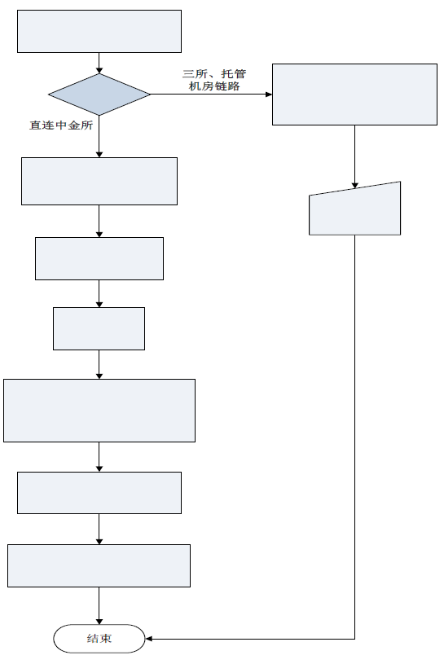
Access via "Three-Exchange Connection", or custodian connection

End
Direct Connection
The applicant configures the circuit, applies for seat IP binding, conducts connectivity and switch tests.
After testing, the applicant completes the test report and send it via e-mail to tech_support@cffex.com.cn
The Exchange sends the circuit configuration information and the templates of Attachment 1.6: Circuit Connectivity Test Report and Attachment 1.7: Circuit Switch Test Report to the owner via e-mail.
The Exchange grants approval.
The Exchange receives a work order from the ISP.
The applicant applies to ISP for circuit accessing.
The applicant faxes the filled Attachment 1.1: Circuit Accessing Application Form with the company seal on it to 021-50160500.
The applicant submits the seat IP binding application via the member service system.
Access type?
Circuit accessing application
P.S.
1． For companies applying for a direct connection to the Exchange
1) The applicant submits an application to SFFIT (logs in www.cffex.com.cn, downloads the template of Attachment 1.1: Circuit Accessing Application Form, and sends the filled form with the company seal on it to tech_support@cffex.com.cn).
2) The applicant requests the ISP to submit a work order to the Exchange upon completion of the configuration. Then the Exchange carries out operations in accordance with the work order. After that, the applicant will receive the templates of Attachment 1.6: Circuit Switching Test Report and Attachment 1.7: Circuit Connectivity Test Report.
3) The applicant conducts connectivity and switching tests during non-trading time and sends the test reports to tech_support@cffex.com.cn with titles in the format of: “Member’s Name (abbreviation)_circuit test”.
4) It is prohibited to use the circuit for trading before testing or before handing the testing report to the Exchange.
5) A member is suggested to cautiously conduct seat IP binding and login tests after accessing a new circuit.

2. For companies applying for access to the Exchange via "Three-Exchange Connection", i.e. Shanghai Futures Exchange, Zhengzhou Commodity Exchange, and Dalian Commodity Exchange, or custodian connection:
1) The company submits an application for seat IP binding on the member service system for the review and approval of the Exchange.
2) Upon approval, the owner may conduct the circuit test and the seat login test.

Chapter 3 Procedures for circuit cancelling
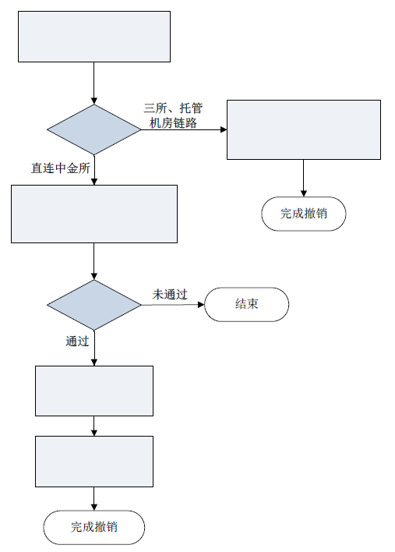
Access via "Three-Exchange Connection", or custodian connection
Complete the cancellation.
The owner deletes the seat IP of the circuit in the member service system.
The applicant applies to ISP for cancellation.
The Exchange performs review
Approved
Not approved
End
Complete the cancellation.
Direct connection

The applicant faxes the filled Attachment 1.3: Circuit Cancelling Application Form with the company seal on it to 021-50160500.
The applicant deletes the seat IP of the circuit in the member service system.
Access type?
Circuit cancelling application

P.S.
1. The applicant submits a circuit cancellation application (logs in www.cffex.com.cn, downloads the Attachment 1.3: Circuit Cancelling Application Form, and sends the scanned copy with the company seal on it to tech_support@cffex.com.cn).
2. The applicant shall confirm that the circuit conditions still meet relevant requirements of the Exchange for circuit backup after cancellation. The applicant shall ensure that the cancellation does not affect normal operations.
3. It is prohibited to cancel the circuit without Exchange’s approval.

Chapter 4 Procedures for Circuit Changing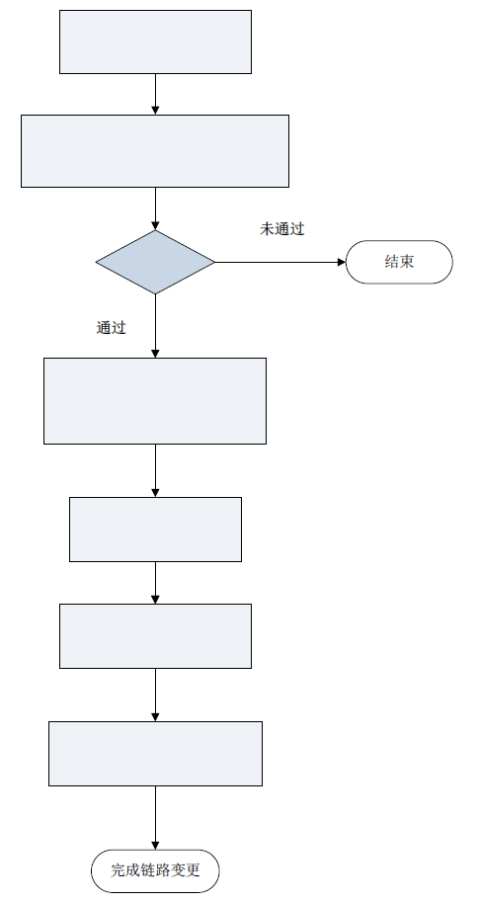
Complete the circuit changing
After testing, the applicant sends the test reports via e-mail to
tech_support@cffex.com.cn
The applicant configures the circuit and conducts connectivity and switching tests.
The applicant submits a changing applicant to the ISP.
The Exchange sends the templates of Attachment 1.6: Circuit Connectivity Test Report and Attachment 1.7: Circuit Switching Test Report to the applicant via e-mail.
Approved
End
Not approved
The Exchange performs review
The applicant faxes the completed Attachment 1.5: Circuit Changing Application Form with the company seal on it to 021-50160500.
Circuit Changing Application
P.S.
1． Only companies with a direct connection to CFFEX can apply for a change. The applicant submits a circuit changing application (logs in www.cffex.com.cn, downloads the Attachment 1.5: Circuit Changing Application Form, and faxes the form with the company seal on it to 021-50160500).
2． Upon the review and approval of the Exchange, the applicant will receive the templates of Attachment 1.6: Circuit Switching Test Report and Attachment 1.7: Circuit Connectivity Test Report.
3． The applicant conducts circuit connectivity and switching tests during non-trading period, and sends the test reports to tech_support@cffex.com.cn with titles in the format of : “Member’s Name (abbreviation)_circuit test”.
4． It is prohibited to use the circuit for trading before testing or before handing the testing report to the Exchange.
5． The Exchange suggests that companies conduct circuit tests and seat login tests during non-trading time to ensure that the access circuit meets the requirements of the Exchange.

Chapter 5 Communication Circuit Interruption and Network Change Reporting
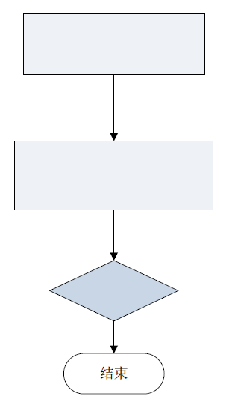
The applicant sends the filled Attachment 1.8: Company Circuit Interruption / Network Change Reporting via email to: tech_support@cffex.com.cn
End
The Exchange places the documents on file.
Network Device Change / Planned Circuit Interruption

P.S.
- The member shall complete and submit the Attachment 1.8 when the interruption is planned or when it needs help from the Exchange with the network change. It is unnecessary for the member to complete and submit the Attachment 1.8 when unplanned circuit failure happens or when it does not need help from the Exchange with the network change.
2． The reporting procedures are only applicable to the companies with a direct connection to CFFEX.
3． Circuit changing (circuit switchover and relocation) is not in the scope of reporting. Please refer to Chapter 4: Circuit Changing Procedures.
4． The member shall submit the form to the Exchange prior to the network change or planned circuit interruption (log in www.cffex.com.cn, download the template of Attachment 1.8: Communication Circuit Interruption / Network Change Reporting, send it to tech_support@cffex.com.cn with titles in the format of “Member’s Name (abbreviation)_interruption reporting”..
5． After submitting the report, the member shall confirm and cooperate with the Exchange on relative issues.

Chapter 6 Suggestions On Circuit Testing

6.1 Preparation For Test Environment
Personnel preparation - deploying personnel dedicated to each phase of test including preliminary preparation, test operation, data recording, summary, etc.
Device preparation – preparing both main and backup circuits with trading capacity, network devices and hosts that can be used for mock trading.
Environment preparation - setting up the network environment based on the specific plan.

6.2 Test Plan
Members shall make the detailed testing plans according to the conditions of their own systems. They may refer to the following cases:
Case I: Circuit Connectivity Test
The member has already been connected to CFFEX directly. The circuit connectivity test is performed on the member-end router. PING the IP address of the opposite-end router. Use the extended PING to perform the test, check the packet loss, delay, and determine whether the circuit is operating normally. Under normal circumstances, packet loss shall be 0, and average delay shall be around 30ms. If delay exceeds 50ms, application may be affected. As delay is affected by transmission distance, it may exceed the above-mentioned reference level when the distance between the Exchange and the testing scene exceeds 1,000km.
Command:

Route#ping
Protocol [ip]:
Target IP address: 10.48.103.62 (IP address of the Exchange end)
Repeat count [5]: 1000
Datagram size [100]: 1500
Timeout in seconds [2]:
Extended commands [n]:
Sweep range of sizes [n]:
Type escape sequence to abort.
Sending 1000, 1500-byte ICMP Echos to 10.48.103.62, timeout is 2 seconds:
!!!!!!!!!!!!!!!!!!!!!!!!!!!!!!!!!!!!!!!!!!!!!!!!!!!!!!!!!!!!!!!!!!!!!!
!!!!!!!!!!!!!!!!!!!!!!!!!!!!!!!!!!!!!!!!!!!!!!!!!!!!!!!!!!!!!!!!!!!!!!
!!!!!!!!!!!!!!!!!!!!!!!!!!!!!!!!!!!!!!!!!!!!!!!!!!!!!!!!!!!!!!!!!!!!!!
!!!!!!!!!!!!!!!!!!!!!!!!!!!!!!!!!!!!!!!!!!!!!!!!!!!!!!!!!!!!!!!!!!!!!!
!!!!!!!!!!!!!!!!!!!!!!!!!!!!!!!!!!!!!!!!!!!!!!!!!!!!!!!!!!!!!!!!!!!!!!
!!!!!!!!!!!!!!!!!!!!!!!!!!!!!!!!!!!!!!!!!!!!!!!!!!!!!!!!!!!!!!!!!!!!!!
!!!!!!!!!!!!!!!!!!!!!!!!!!!!!!!!!!!!!!!!!!!!!!!!!!!!!!!!!!!!!!!!!!!!!!
!!!!!!!!!!!!!!!!!!!!!!!!!!!!!!!!!!!!!!!!!!!!!!!!!!!!!!!!!!!!!!!!!!!!!!
!!!!!!!!!!!!!!!!!!!!!!!!!!!!!!!!!!!!!!!!!!!!!!!!!!!!!!!!!!!!!!!!!!!!!!
!!!!!!!!!!!!!!!!!!!!!!!!!!!!!!!!!!!!!!!!!!!!!!!!!!!!!!!!!!!!!!!!!!!!!!
!!!!!!!!!!!!!!!!!!!!!!!!!!!!!!!!!!!!!!!!!!!!!!!!!!!!!!!!!!!!!!!!!!!!!!
!!!!!!!!!!!!!!!!!!!!!!!!!!!!!!!!!!!!!!!!!!!!!!!!!!!!!!!!!!!!!!!!!!!!!!
!!!!!!!!!!!!!!!!!!!!!!!!!!!!!!!!!!!!!!!!!!!!!!!!!!!!!!!!!!!!!!!!!!!!!!
!!!!!!!!!!!!!!!!!!!!!!!!!!!!!!!!!!!!!!!!!!!!!!!!!!!!!!!!!!!!!!!!!!!!!!
!!!!!!!!!!!!!!!!!!!!
Success rate is 100 percent (1000/1000), round-trip min/avg/max = 24/27/44 ms

Case II: Switching Test A: Between Main and Backup Circuits
A member has two circuits connected directly to the Exchange which has been tested and operates normally. Before test, a tester performs mock-trading on the test device A, and continuously perform PING test on the front-end trading device. The China Telecom Circuit is firstly used for data trafficking during mock-trading (as shown in the following picture).Data shall be recorded in the report.
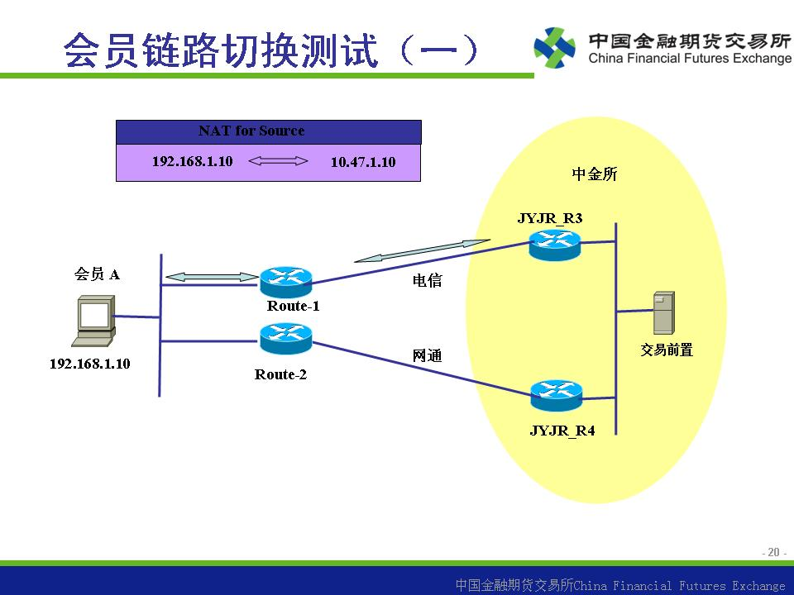
China Unicom
China Telecom
Member Circuit Switching Test (A)
Member A
Trading Front
CFFEX
Disconnect the China Telecom circuit, either manually or automatically, and transfer the data traffic of device A through the China Unicom Circuit (as shown in the following picture). Record the packet loss of the PING packets and the time interval from interruption to recovery. Record relevant data in the test report (see Attachment 2).
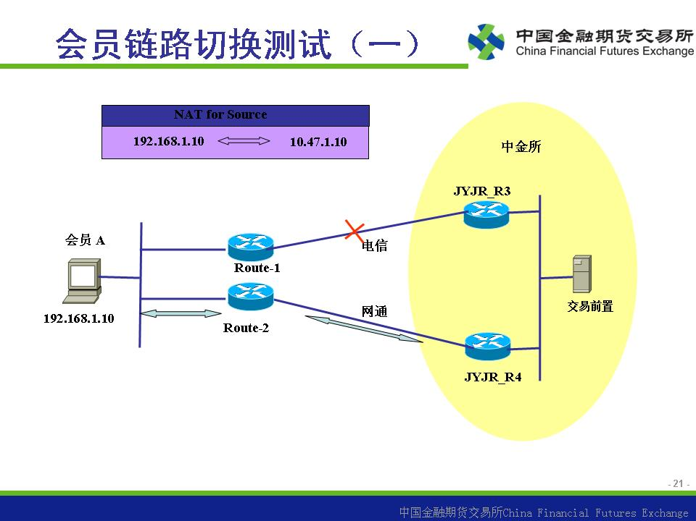
China Unicom
Member Circuit Switching Test (A)
China Telecom
Member A
Trading Front
CFFEX
After the above switching, connect the device to the main circuit again and record relevant data in the test report.

Case III: Switching Test B: Between Main and Backup Circuits
A member has a main circuit directly connected to the Exchange and a backup circuit accessed via the three exchanges. Before test, a tester performs mock-trading on the test device A, and continuously perform PING test on the front-end trading device. The direc Circuit is firstly used for data trafficking during mock-trading (as shown in the following picture).Data shall be recorded in the report.

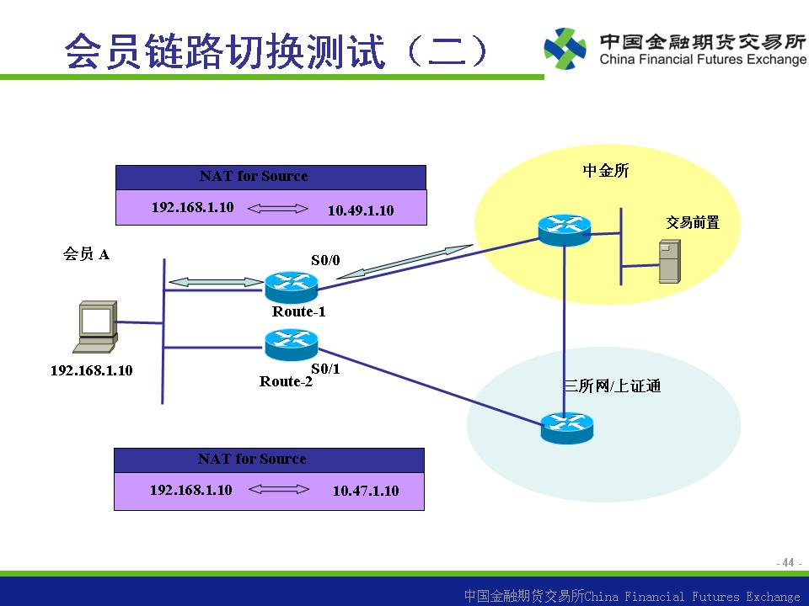
The Three Exchanges /
Shanghai Stock Exchange Technology Company
Trading Front
CFFEX
Member A
Member Circuit Switch Test (B)
Disable the network adapter of the China Telecom circuit manually, and transfer the data traffic via the Three Exchanges / Shanghai Stock Exchange Technology Company circuit (as shown in the following picture). Record the packet loss of the PING packets and the time interval from interruption to recovery. Record relevant data in the test report (see Attachment 2).
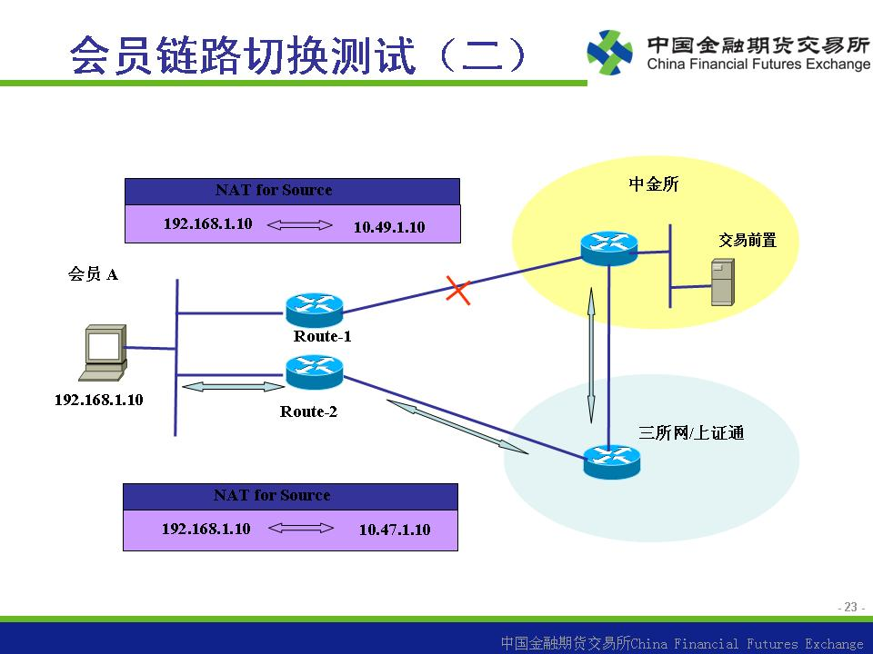
The Three Exchanges /
Shanghai Stock Exchange Technology Company

Member A
Trading Front
CFFEX
Member Circuit Switch Test (B)

After the above switching, connect the device to the main circuit again and record relevant data in the test report.

